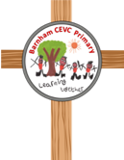

**Barnham CEVC Primary School**

**SPECIAL EDUCATIONAL NEEDS AND DISABILITIES**

**(SEND) POLICY**

**Intent**

Barnham CEVC Primary school is committed to enabling children to flourish and achieve their fullest potential through providing opportunities to be ‘the best they can be for themselves, for others and for God’s world’. We want all children to feel respected and valued as contributors to our school family.

Barnham CEVC Primary School is an inclusive school. We take safeguarding very seriously and all of our policies are developed with a high priority on children’s safety and in the light of our Safeguarding policy. All of our school policies are interlinked and should be read and informed by all other policies. In particular, the SEND policy is linked to behaviour, anti-bullying, medical and curriculum policies.

This SEND policy is written to comply with the 2014 Children and Families Act and its SEN Code of Practice together with the Equality Act 2010 and ‘Keeping Children Safe in Education 2022’. **The purpose of this policy is to set down the procedures by which the school provides support for pupils with Special Educational Needs and disabilities.**

At Barnham we embrace the fundamental principles of the SEN Code of Practice 2015. These principles make up our aims:

1. to meet the educational needs of all pupils and encourage each one to develop their full potential
2. to give all pupils individual consideration, providing special provision where necessary with support from other agencies
3. to facilitate full participation in the Curriculum and all school activities, giving equal access to a broad and balanced curriculum for children as far as they are able.
4. to encourage pupils to become independent and take responsibility within the school

**ROLES & RESPONSIBILITIES**

Everyone has a part to play in achieving these aims:

***Parent/Carers*** the school recognises the role of the parent as the primary educator and carer of the child. They will be consulting and working collaboratively with school to meet their child’s needs and to develop a joint learning approach at home and school and a positive and supportive working relationship.

***Class teachers*** in the first instance, the class teacher will be responsible for delivering high quality teaching differentiated and adapted for individual pupils, identifying any possible SEN concerns and liaising with the parents and Special Educational Needs Coordinator.

***Governors*** by fulfilling their statutory duties to pupils with special education needs; by securing appropriate resources; by establishing a policy in line with the Code of Practice regarding the identification and assessment of special education needs and by participating in appropriate training.

***All Staff*** by maintaining a positive approach to supporting all children including those with SEND, implementing the principle that every member of staff is directly responsible for meeting the needs of all pupils, by working with the SENCo (Special Educational Needs Co-ordinator), pupil, parents and other agencies and by participating in appropriate training.

***Pupils*** by actively taking part in all decision-making processes that occur in their education.

***Local Authority*** The local authority must consult parents of children with SEND in the development of its policies. Where a child requires an EHC needs assessment, it must ensure that the child's parents are fully included in the process from the start, are fully aware of their opportunities to offer views and information, and are consulted about the content of the plan.

**SEND TEAM AT BARNHAM CEVC PRIMARY SCHOOL**

**Miss Rachel Bacon**

**SENDCo**

[rbacon@barnham.org](mailto:rbacon@barnham.org)

(01842) 890253

As SENDCo at Barnham, I am responsible for:

* Coordinating provision for children with SEND and developing the school’s SEND policy.
* Ensuring that parents are:
  + Involved in supporting their child’s learning and access.
  + Kept informed about the range and level of support offered to their child.
  + Included in reviewing how their child is doing
  + Consulted about planning successful movement (transition) to a new group or school
* Liaising with a range of agencies outside school who can offer advice and support to help students overcome any difficulties.
* Providing specialist advice and facilitating training to ensure that all staff are skilled and confident about meeting a range of needs.

I work alongside an amazing team of staff who will journey with you and your child at Barnham.

**Mrs Amy Arnold - Headteacher**

she is responsible for:

The day to day management of all aspects of the school, including the provision made for students with SEND.

**Mrs Rhonda Tasker**

**Family Support Practitioner**

she is responsible for:

Leading Mental Health at Barnham and supporting families and pupils in school with SEMH needs.

**Mrs Sarah Brett**

**SEND Governor**

who is responsible for:

Supporting our school to evaluate and develop the quality and impact of provision for students with SEN across the school.

**Mrs Moira King**

**Learning Mentor**

who is responsible for:

Working directly with children with SEND carrying out assessments and specific interventions as advised by SENDCo.

**Any of these individuals can be contacted through the school office who would be happy to make an appointment for you.**

**DEFINITION OF SEND**

Children have SEND if they have a learning difficulty that calls for additional educational provision to be made for them. ‘Children have a learning difficulty if they:

* Have a significantly greater difficulty in learning than the majority of children of the same age.
* Have a disability that prevents or hinders them from making use of educational facilities of a kind generally provided for children of the same age in schools within the area of the local authority.
* Are under compulsory school age and fall within the definitions above or would so do if special educational provision was not made for them.’ (Code of Practice September 2014)

At Barnham, we use the terms SEND and additional needs.

The Code of Practice (DfE, January 2015) states that: A person has SEN if they have a learning difficulty or disability which calls for special educational provision to be made for him or her. At compulsory school age this means he or she has a significantly greater difficulty in learning than the majority of others the same age, or, has a disability which prevents or hinders him or her from making use of facilities of a kind generally provided for others of the same age in mainstream schools. Taken from 2014 SEN Code of Practice: 0 to 25 Years.

Slow progress and low attainment do not necessarily mean that a child has SEND and will not automatically result in a child being identified as SEND. On the other hand, additional support is not limited to children identified as SEND but we recognise that many children need additional support and will always do our very best to ensure appropriate provision is in place.

#### **FOUR BROAD AREAS OF SEND**

The SEND Code of Practice 2014 (updated January 2015) sets out four broad areas of special educational need that include a range of difficulties and conditions:

* Communication and Interaction
* Cognition and Learning
* Social, Emotional and Mental Health (SEMH)
* Sensory needs and Physical Disabilities

|  |  |  |  |
| --- | --- | --- | --- |
| **Communication and Interaction Needs** | **Cognition and Learning Difficulties** | **Social, Emotional and/ or Mental Health Needs** | **Sensory and/or Physical Needs** |
| Speech, language and communication needs  Autism Spectrum Conditions | Specific learning difficulties eg: Dyslexia, Dyscalculia  Moderate learning difficulties  Severe learning difficulties  Profound and multiple learning difficulties | Attention Deficit Hyperactivity Disorder (ADHD)  Anxiety  Depression  Eating Disorders  Mental Health concerns  Challenging or concerning behaviour | Visual Impairment  Hearing Impairment  Multi-sensory Impairment  Physical Disability |

The lists in the table above are not exhaustive and The SEND Code of Practice states that:

Many children and young people have difficulties that fit clearly into one of these areas; some have needs that span two or more areas; for others the precise nature of their need may not be clear at the outset.

The code of practice provides statutory guidance for organisations that work with and support children and young people with special educational needs and disabilities.

**SEND AT BARNHAM CEVC PRIMARY SCHOOL**

Our objectives are:

* To identify, at the earliest possible opportunity, barriers to learning and participation for pupils with SEND; (see also curriculum and assessment policies)
* To ensure that every child experiences success in their learning and achieves to the highest possible standard;
* To enable all children to participate in lessons fully and effectively
* To value and encourage the contribution of all children to the life of the school
* To work in partnership with parents
* To work with the Governing Body to enable them to fulfil their statutory monitoring role with regard to the Policy Statement for SEND
* To work closely with external support agencies, where appropriate, to support the need of individual pupils
* To ensure that all staff have access to training and advice to support quality teaching and learning for all pupils

This school will assess each pupil’s current skills and levels of attainment on entry, building on information from previous settings and key stages where appropriate. We will consider evidence that a pupil may have a disability under the Equality Act 2010 and, if so, what reasonable adjustments may need to be made for them.

Teachers are responsible and accountable for the progress and development of the pupils in their class, including where pupils access support from teaching assistants or specialist staff. High quality teaching, adapted learning for individual pupils, is the first step in responding to pupils who have or may have SEND.

The school will take a graduated approach: the majority of children with SEND will have their needs met within the school. Some children may require an Educational Health and Care needs assessment in order for the local authority to decide whether it is necessary for it to make provision in accordance with an EHC plan.

The purpose of an EHC plan is to make specific and/or additional provision to meet the special educational needs of the child, to secure the best possible outcomes for them across education, health and social care.

The school will maintain a record of those pupils who are currently receiving SEND support or who have previously received support. This is called the SEND register.

**Implementation**

**ADMISSIONS**

This school follows the Suffolk County Council Co-ordinated Admissions Policy. Places will be offered to those children with an EHC Needs Plan that names the school as the appropriate school for the child, even if it is not the catchment school. In making the decision to name a school, parents’ views will be considered carefully by local authority staff.

Parents who wish to see if this school is suitable for their child can find details of our local offer for pupils with SEND on our website [www.barnham.suffolk.sch.uk](http://www.barnham.suffolk.sch.uk) The best way to find out if this school will meet your child's needs is to visit the school. Please contact us to arrange an appointment. Parents will be responsible for transporting their child to the school if they do not qualify for free or discretionary transport under the Suffolk County Council home to school transport policy. Please contact SCC for further information: 0845 606 6173.

**IDENTIFICATION AND ASSESSMENT OF CHILDREN WITH SEND**

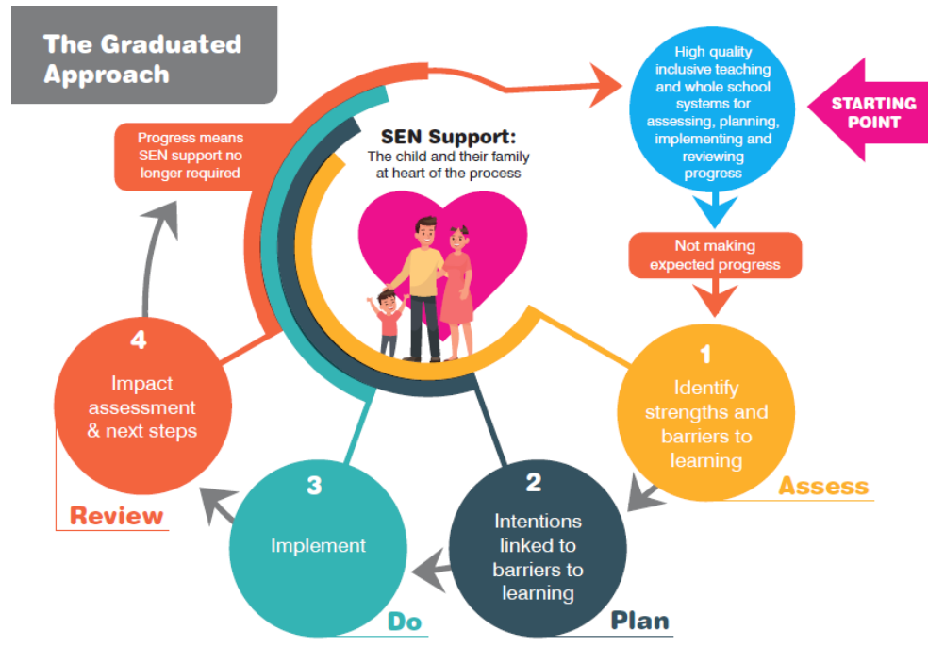

As set out in the SEND Code of Practice, the school follows the **Graduated Approach to Assessment**, which follows the four stages of Assess, Plan, Do and Review. This allows for a more personalised approach to the identification, planning and assessment of SEND provision.

We also use The SEND Journey document from Suffolk to inform our procedures as outlined here.

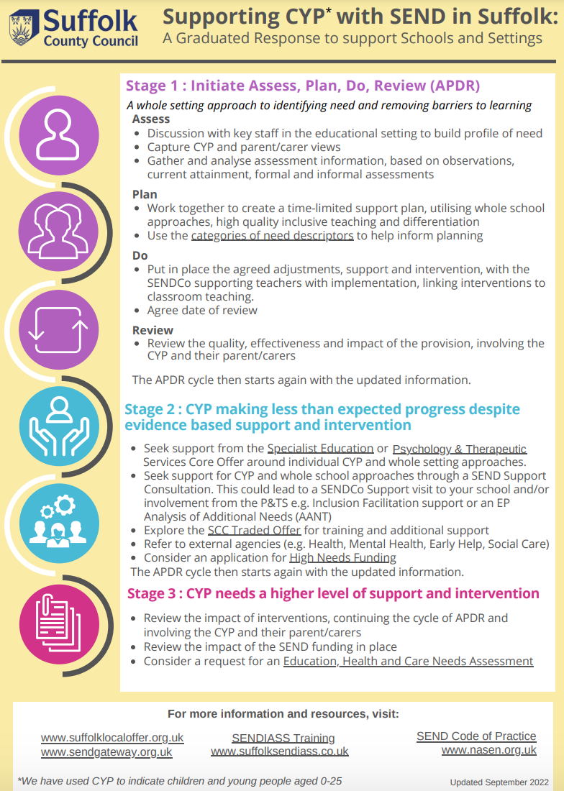

The SEND journey and process at Barnham is outlined below and will help you understand the process for identifying children with SEND, our ‘step up’ procedure for adding children to the SEND register and also our ‘step down’ procedure which explains when and why a child might be removed from the SEND register.

#### **/var/folders/mk/w6566v513znc3mttccv5bk380000gn/T/com.microsoft.Word/Content.MSO/DE0EE1FF.tmpOur Graduated Response Working TOGETHER to support a child’s SEND Journey at Barnham**

If you are worried your child may be struggling,

**Please talk to us**

Check in with your child’s class teacher, they know your child best. E mail them or call and ask for a mutually convenient appointment to discuss your concerns.

Then the following the steps may happen:

#### Eye Icon And Alternative Icon For Observe Action - Observation Icon Png Transparent PNG - 2500x1200 - Free Download on NicePNG**Step 1: Observations (Wave 1)**

*The class teacher will make observations and assessments and talk to the SENDCo about the findings in order to plan next steps. (Assess-Plan)*

**Step 2: Implementation (Wave 1)**

The class teacher will then implement some of the suggestions discussed (Do) and then review after a period of time, usually around half a term (Review). This may mean that they make reasonable adjustments in class or your child may join a specific intervention group.

***After the steps above, it may be that we are identifying a Special Educational Need and then the next steps maybe carried out:***

**Step 3: Identification of SEND (Wave 2)**

***Step 3 is considered our ‘Step Up’ point and at this point the child will be added to our school SEND register***

In school we have a selection of different assessments and screenings that we can use to look for specific difficulties.

We may also seek to refer the child for further investigation from health professionals; this process will be carried out with parents.

The SENDCo may also seek to get further advice from an outside agency but this will be done in conversation with the child’s parents/carers.

**Step 4: Assess- Plan- Do- Review (Wave 2)**

Class teachers will work with the child and family to create a written plan. The SENDCo may advise on the contents of this plan. It will outline targets for the child to work on and the provision that will be put in place to support them. These plans are called ‘Learning Plans’ as we hope these plans will support a child in their journey of learning, making progress and becoming the best that they can be.

**LEARNING PLANS**

Learning plans record specific and challenging targets for the child to achieve over a set period of time (usually one term). These plans will also outline the personalised provision (which may be 1-1 or in a small group) put in place to enable the child to achieve these targets. The ‘Learning Plans’ will be reviewed termly by all to ensure good progress or even better.

This is all part of the graduated approach of assess, plan, do and review. The school expectation is that there will be at least 3 cycles of these each year but in some cases there may be more.

Our learning plans are generated using the school’s assessment programme called Insight. They will usually be 2x A4 sides and look similar to the images below:

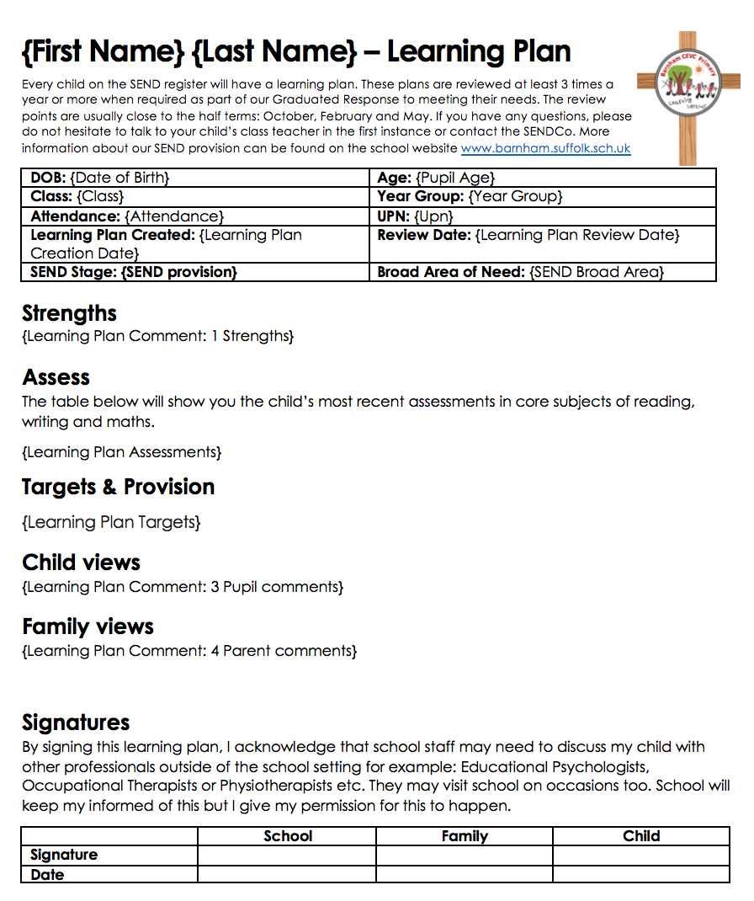

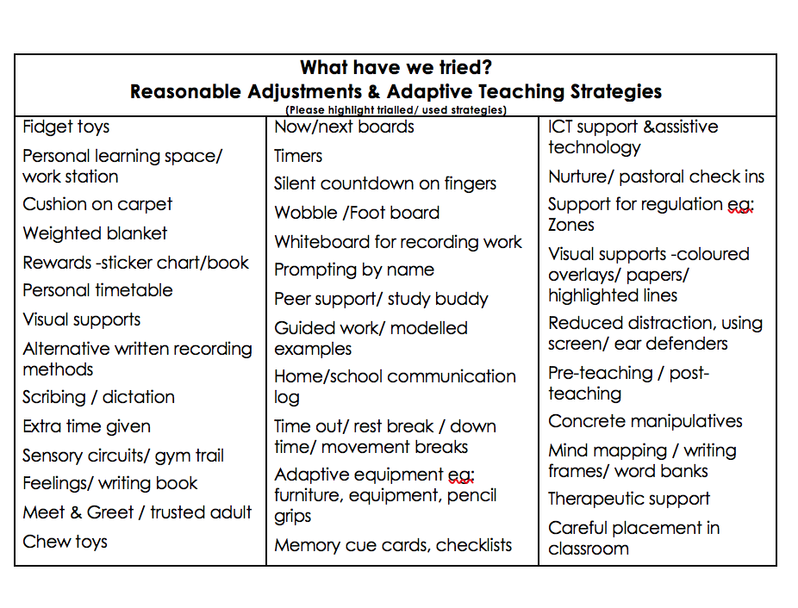

***After the steps above, it may be that a child has a significant, long-term SEND. If this is the case then school and family will meet to discuss whether it is going to be necessary to apply for an Educational Health Care Needs Assessment (EHCNA)***

****As the code of practice explains “The majority of children and young people with SEND will have their needs met within local mainstream early years settings, schools or colleges, (like Barnham). Some children and young people may require an EHC needs assessment in order for the local authority to decide whether it is necessary for it to make provision in accordance with an EHC plan. The purpose of an EHC plan is to make special educational provision to meet the special educational needs of the child or young person, to secure the best possible outcomes for them across education, health and social care and, as they get older, prepare them for adulthood.”

**Step 4 will be repeated at least twice so that the school have a wealth of evidence to use as part of the EHCNA request**

**Step 5: Request an EHCNA which may lead to the child obtaining an EHCP (Wave 3)**

At this point, various professionals and specialists will have worked with the child in order to gain a full picture of their needs.

A referral will then be sent to the child’s home county local authority (Suffolk or Norfolk). It is then up to the authority to decide whether the EHCNA will take place.

If the panel decide that this should happen, the full assessment process should be completed within 20 weeks.

**EDUCATION & HEALTH CARE PLAN (EHCP)**

**The percentage of pupils with an EHC Plan in England is currently around 4%.**

Please bear in mind that Parents can apply for an EHC needs assessment (often referred to as an EHCNA) or the school can. It will take the school a significant amount of time to put together the referral paperwork and evidence required for this before the 20-week process will begin.

Please note that if you submit a parental request for an EHC, the local authority will then contact the school to request information from them. We are usually given a 14-day deadline in which to do this. Therefore, please may we encourage you to notify the school of your intention to apply for an EHC plan. If your request is sent to the local authority during a period of school closure eg: summer holidays, it may be difficult for the school to meet this deadline which may result in the local authority refusing to assess and then a resubmission of the paperwork may need to occur again once the school has reopened. Please remember this if you are going to submit a parental request. If you contact the SENDCo to discuss your intentions to submit a parental request for an EHCP she can further explain the dates and the process to you.

This diagram may also help to explain the 20-week process following the local authority receiving an EHC request either from parents or the school:

Children whom we think will manage in mainstream schools, albeit with support, are less often assessed for EHC Plans.

Having a diagnosis (eg of ASD, ADHD or Dyslexia) does not mean that a child needs an EHC Plan. Equally, a child does not need to have a diagnosis to obtain a plan. They are based on the needs the child presents.

**ANNUAL REVIEWS**

If the application for an EHC Plan is successful and a child secures an EHCP. The school at the instruction of the Local Authority (LA) will call a meeting for parents, the child and the school together with any health or social care professionals who are involved with the family annually. This is called an Annual Review. The meeting will record the child’s strengths, their dreams and aspirations as well as the barriers they face. Following the meeting, the LA will adjust the EHC Plan which will record the decisions made at the meeting.



**At any point on the SEND journey and in consultation with parents/ carers, a child may be considered for removal from the SEND register where they have made sustained good progress that:**

* + - **betters the previous rate of progress and has sufficiently closed the attainment gap between the child and their peers of the same age.**
    - **or where a child’s wider development and/or social needs have improved and progress in the targeted area is considered to be sustained and SEND support is no longer required to ensure that this level of progress is sustained.**

**This is called our ‘Step-Down’ Procedure.**

**All children are regularly monitored and can begin the SEND journey again if required.**

**DIAGNOSIS**

At Barnham, we aim to meet the identified needs of children and young people, irrespective of their diagnosis.

It is important to understand that just because a child has a diagnosis, this does not mean that a child has to be on the SEND register if they are making progress in school through our universal offer or ordinarily available provision.

If you are concerned that your child may have neurodevelopmental challenges, you may wish to discuss getting them diagnosed with the school. We can access support through the NDD Pathway. More information about this can be found by visiting, <https://www.barnardos.org.uk/what-we-do/services/suffolk-neurodevelopment-pathway>

Barnados act as the gateway for this service.

We also acknowledge that some families choose not to have their child diagnosed and wish to emphasise that provision at Barnham school is needs led rather than diagnosis based.

**PRIVATE ASSESSMENTS**

We recognise that the wait to be seen by medical professionals when seeking a diagnosis can be significant.

Some families may choose to have their children assessed privately. **We would strongly encourage you to speak to school staff before pursuing this route.**

Private assessments will be dealt with and considered on a case-by-case basis.

Various private companies will probably wish to speak to the school regarding the child’s needs and usually request various pieces of paperwork are completed including questionnaires. We will endeavour to do this within a reasonable time frame, however please be aware that this may not be within the time-frames given by these companies particularly at busy periods of the academic year.

If a diagnosis is given, there is no reason why a diagnosis should be ignored simply because it was obtained privately. You are more than welcome to share a copy of the report and diagnosis with the school should you choose to.

It is important to understand that some of the recommendations suggested by private professionals are not always reasonable and within our remit to provide as a local authority-maintained school but we can discuss the content of the report with families and plan next steps forward in line with this policy and our graduated response.

If seeking a private assessment please ensure that processes and diagnoses meet the same standards as those expected of the NHS.

If an assessment completed by a privately funded provider or practitioner complies with National Institute of Clinical Excellence (NICE) guidelines, then it should be considered equivalent to an NHS assessment and should be treated as such. NICE guidelines can be found here:

**Autism Spectrum Condition Diagnosis in under 19s**

<https://www.nice.org.uk/guidance/cg128>

**Attention Deficit Hyperactivity Diagnosis in under 19s**

<https://www.nice.org.uk/guidance/ng87>

It is important to note that not all assessments carried out privately meet the suggested criteria. Please check before proceeding with any private assessment that it will meet the necessary standards:

* Autism assessments must be conducted by a multidisciplinary team of appropriately trained and qualified clinicians. In practice, this means that at least two clinicians from different professional backgrounds must be directly involved in the assessment. This may be a Practitioner Psychologist (Clinical or Educational), Paediatrician, Psychiatrist, Speech and Language Therapist, or Occupational Therapist.
* Whilst it is often beneficial for ADHD assessments to be conducted by a multidisciplinary team, this is not essential as one appropriately trained and qualified clinician is considered sufficient for the diagnosis of ADHD.
* The clinician(s) involved in an Autism or ADHD assessment must be registered with an appropriate professional body [e.g. Health and Care Professions Council (HCPC) or General Medical Council (GMC)].
* All Autism and ADHD assessments must gather a comprehensive history of general development. This must have included gathering information about biological, social, environmental and psychological factors that might have impacted the young person’s development.
* All Autism and ADHD assessments must have gathered information from multiple sources about a young person’s possible areas of difference across their lifespan. This should involve in-depth discussions with the young person if they are able to engage in these conversations, in addition to their parent carer and others who know the young person well (e.g. teachers, practitioners from other settings, other key people in the young person’s life).
* All Autism and ADHD assessments must have involved at least some interactional and/or observational assessment with the young person directly. Whilst this can in some circumstances be via online video assessment, information from other sources must be sufficient to compensate for this.
* Any appropriate alternative or additional explanations for a young person’s experiences or areas of difference have been adequately considered and assessed. This might include considering whether a young person’s needs are better understood in terms of other diagnoses including a Learning Disability Developmental Language Disorder, or Fetal Alcohol Spectrum Disorder.
* It might also include considering whether a young person’s experiences may be better understood as a response to difficult or traumatic life events, a mental health concern, relational or attachment-based concerns, or developmental trauma. It is important to remember that young people with needs relating to these areas can appear similar to those who are Autistic or have ADHD.

Please be aware that the school is unable to recommend private companies for you to use

**PROVISION AT BARNHAM CEVC PRIMARY SCHOOL**

The pyramid charts that follow will show the provision that we have in place for children at Barnham. It outlines our ‘Universal Offer’ or our ‘Ordinarily Available Provision’ (OAP) that is available for every child.





**Children can move up and down based on the provision they are receiving which will be based on the needs that they are presenting in school.**





**Our provision at any wave may include additional adult support, adaptive teaching strategies or intervention programmes.**

Outside Agency Support that we may access at wave 2 or 3 could include: Family Support Practitioner, Mental Health Support Team, Educational Psychologist, Speech and Language Therapist Occupational Therapist, Family Services, SES, School Nursing Team and others as appropriate.

The following pyramid diagrams will explain our provision for each of the broad areas of need, these provisions are not exhaustive as we are regularly reading new research and responding to the needs of pupils, taking on advice from professionals and seeking to improve our offer and support all the time.

**Communication & Interaction Needs at Barnham**

* Differentiated curriculum planning, activities, delivery and outcome e.g. simplified language
* Increased visual aids / modelling etc
* Visual timetables
* Use of symbols
* Structured school and class routines
* In class support
* SALT support
* Becoming socially talented programme
* Social stories
* Lego therapy
* Visual cues and resources
* Support from Family Support Practitioner
* 1:1 intervention
* Personalised timetable
* Use of workstation
* Assistive technology to support learning
* Attention Autism / Intensive Interaction
* Communication Systems eg: PECS

**Cognition and Learning Needs at Barnham**

* Differentiated learning opportunities and adaptive teaching strategies used.
* Access to irresistible leaning opportunities through a broad and balanced curriculum.
* Teacher and Teaching Assistant support, guidance and modelling.
* Practical and active learning opportunities with concrete manipulatives and high quality resources including assistive technology.
* Opportunities for outdoor learning opportunities
* Access to small group work, support and interventions.
* More visual supports eg: task cards, check lists, visuals, word banks etc.
* Opportunities to access pre and post teaching to support their learning and understanding.
* Additional reading with an adult.
* Scaffolded learning
* 1:1 or small group interventions
* 1:1 support to access curriculum
* Personalised curriculum
* Use of a workstation
* Assistive technology to support learning eg: laptop, ipad

Ue

**Social, Emotional & Mental Health Needs at Barnham**

* Whole school positive behaviour rewards system
* Whole school thrive approach
* Zones of regulation
* Circle time
* Family support with Family Support Practitioner
* Lots of outdoor learning opportunities
* ELSA
* Thrive groups
* Human toolbox
* Forest School
* Social skills group
* Extra transition support
* Drawing and talking
* Pastoral check ins
* Brain breaks/ physical breaks
* Calming/ fidget toys
* Home school records for communication
* Individualised approach with reward systems
* 1:1 Therapeutic Intervention
* Reduced timetables /soft start to school
* Alternative provision/ dual placements
* Meet and greets/ transition support

**Sensory & Physical Needs at Barnham**

* Flexible teaching arrangements
* Trained staff aware of physical impairments
* Writing slopes/ Pencil grips
* Use of computers
* Flexible teaching arrangements
* Staff aware of implications of physical impairment
* Writing slopes
* Pencil grips
* Fine and gross motor skills group
* Concentration aids eg: fidget toys, chewellery
* Active sitting resources and sensory aids eg: ear defenders
* Coloured overlays
* Muscle strengthening activities
* Individual support to access school environment and the curriculum
* 1:1 support to access PE lessons, this may be following a physiotherapy programme
* Support to access play opportunities outside at breaktimes.
* Sensory circuits
* Scribe for writing
* Specialist equipment eg: scissors, chairs, tables, weighted blankets

**WORKING WITH PARENTS**

At Barnham, we are committed to working with parents in the best interests of the child. Parents will be involved in the identification of SEN and informed when the school makes special education provision for the child. Thereafter, parents will be involved in any reviews of provision and the school will ensure that parents are kept regularly informed about their child's progress.

Should parents wish to make a meeting with the SENDCo, they are more than welcome to send her an e mail directly and this can be arranged.

The SENDCo will hold regular coffee mornings throughout the year called CONNECT, all families who have children with SEND will be welcome to attend these events and have the opportunity to network and receive support.

Regular newsletters with a SEND focus will be sent home to families from the SENDCo, these will be called ‘SENDing News’ and will hopefully be a source of support and information.

**FUNDING**

The school will provide resources to support children with SEND as appropriate within the schools delegated budget. Children who have particularly complex needs may qualify for high needs funding in order to provide specific support for their needs.

The SENDCo will apply for this funding with support from Class Teachers. The Headteacher with the Senior Leadership Team (SLT) manages the allocation of funding and resources.

**STAFF TRAINING**

All staff are teachers of children with SEND. A number of staff have received specialist training in specific SEND provision and the SENDCo and Headteacher will deploy staff appropriately. As part of ongoing professional development, the SENDCo and headteacher will arrange training for staff to enable them to meet the needs of pupils with SEND in the school.

**THE CURRICULUM**

All pupils have access to a broad and balanced curriculum at our school. We set high expectations for every pupil, whatever their prior attainment. Teachers use appropriate assessment to set targets that are deliberately ambitious. Lessons are planned to address potential areas of difficulty and to remove barriers to pupil achievement. In many cases, such planning will mean that pupils with SEND and disabilities will be able to follow the full national curriculum.

In line with the school's inclusion policy and equalities policy, no child will be excluded from participation in extra-curricular activities and school trips and the school will endeavor to make all its facilities accessible to all pupils in line with its accessibility plan.

Subject Leaders should consider the needs of all abilities when providing resources for their particular subject areas and the SENDCo works closely with the headteacher to manage the budget for SEND resources.

**TRANSITION AND TRANSFER**

When a child moves school at the normal age of transition, we will engage in thorough liaison with the receiving school to share information and familiarise the pupil with the new environment and provide opportunities for them to meet key members of staff at the new school. Depending on the receiving school and the needs of the child, this will include visits to the school by special needs staff, visits to the receiving school by the pupil, meetings between staff and parents and the sharing of information between the schools. Where transition takes place at other times, we will use our best endeavours to engage in the same way.

**SUFFOLK’S LOCAL OFFER**

Barnham is a Suffolk School and therefore we are supported by the local authority of Suffolk.

The purpose of the local offer is to enable parents and young people to see more clearly what services are available in their area and how to access them. It includes provision from birth-25, across education, health and social care. Suffolk’s local offer is available from the website:

<http://infolink.suffolk.gov.uk/kb5/suffolk/infolink/home.page>

In addition to this,

<https://www.access-unlimited.co.uk>

is the One Stop Shop for Suffolk children and young people with additional needs and disabilities.

It includes information about activities and breaks available for Suffolk children with SEND as well as information for parents about benefits and how Suffolk aim to support children through education, health and social card. Our school offer and more information on our provision for children with SEND and their families can be found on the school website, [www.barnham.suffolk.sch.uk](http://www.barnham.suffolk.sch.uk)

If you live in Norfolk, you can find Norfolk’s local offer online also.

**EQUAL OPPORTUNITIES**

The school is committed to providing equal opportunities for all, regardless of race, faith, gender or capability in all aspects of school. We promote self and mutual respect and a caring and non-judgmental attitude throughout the school.

**SAFEGUARDING AND SEND**

As a school, we are aware that children with special educational needs and disabilities (SEND) can face additional safeguarding challenges. We recognise the fact that additional barriers can exist when recognising abuse and neglect in this group of children. These could include:

• assumptions that indicators of possible abuse such as behaviour, mood and injury relate to the child’s disability without further exploration;

• children with SEND can be disproportionally impacted by things like bullying- without outwardly showing any signs; and

• communication barriers and difficulties in overcoming these barriers.

**COMPLAINTS PROCEDURE**

The governing body will ensure that anyone who wishes to make a complaint in relation to children with SEND, whether they have an EHC plan or not, is treated fairly, given the chance to state their case, provided with a written response (including the rationale for any decisions) and informed of their appeal rights in line with the school's complaints procedure.

In the first instance, any parent or carer with a concern about the implementation of the SEND policy should speak to their child's class teacher or the SENDCo. If they wish to pursue a complaint they should contact the headteacher and follow the school's complaints procedure.

**EVALUATION & REVIEW PROCEDURES**

The governing body can evaluate the success of the policy by assessing how pupils with special educational needs:

• participate in the lessons and the curriculum

• gain independence

• take responsibility about the school

The governing body will also evaluate:

• how resources have been allocated between pupils with special needs

• type of INSET provided

• accuracy of paperwork

The policy will be reviewed annually (or sooner in the event of revised legislation or guidance)

|  |  |
| --- | --- |
| **Review Term:** | Annually |
| **Led member of staff responsible for review:** | Rachel Bacon (SENDCo) |
| **Lead governor responsible for review:**  **(Full GB to approve)** |  |
| **Date adopted:** |  |
| **Dates policy reviewed** |  |
| **Dates policy amended in between reviews** |  |