**KS1 Curriculum Overview**

**2023-2024**

**Reading - Hedgehogs**

| **Autumn** | **Spring** | **Summer** |
| --- | --- | --- |
| **Bear Shaped –** *Dawn Coulter-Cruttenden*  **The Dark –** *Lemony Snicket*  **Luna loves Art –** *Joseph Coelho*  **What Makes Me a Me? –** *Matt Goodfellow*  **William’s Bee’s Wonderful World of Things That Go! –** *William Bee*  **Pumpkin Soup –** *Helen Cooper*  **I’m (Almost) Always Kind –** *Anna Milbourne*  **Standing Up To Racism –** *Dr Pragya Agarwal*  **Celebrations Around the World –** *Katy Hallford* | **Shu Lin’s Grandpa –** *Ben Faulks*  **It’s a No-Money Day –** *Kate Milner*  **Mr Noah’s Garden –** *Jackie Morris*  **Mr Wolf’s Pancakes –** *Jan Fearnley*  **The Invinsible –** *Tom Percival*  **The Squirrels Who Squabbled –** *Rachel Bright*  **Chicken Clicking –** *Jeanne Willis & Tony Ross*  **The Gingerbread Man –** *Mara Alperin* | **Tad –** *Benji Davies*  **Winnie-the-Pooh Helps the Bees! –** *Catherine Shoolbred*  **Clean Up! –** *Nathan Bryon*  **Each Peach Pear Plum –** *Allan and Janet Ahlberg*  **Martha Maps It Out –** *Leigh Hodgkinson*  **The Wonder –** *Faye Hanson*  **Anansi and the Golden Pot –** *Taiye Selasi*  **The Story Orchestra –** *Katy Flint* |
| **In addition to the texts, the following nursery rhymes will be covered:** Head, shoulders, knees and toes; Incy Wincy Spider; Humpty Dumpty, Twinkle Twinkle; Row, Row, Row Your Boat; Wheels on the Bus; Hey Diddle Diddle; Five Little Ducks; Hickory Dickory Dock; Five Currant Buns; Miss Polly; Ten Green Bottles; hot Cross Buns; 1 Potato…; Old Mother Hubbard; Jack and Jill. | | |

*\* Children in Moles will follow Year 1 texts.*

*\*\* Securing and advancing knowledge notes will ensure that children are covering their year’s national curriculum objectives:*

*Eg,* 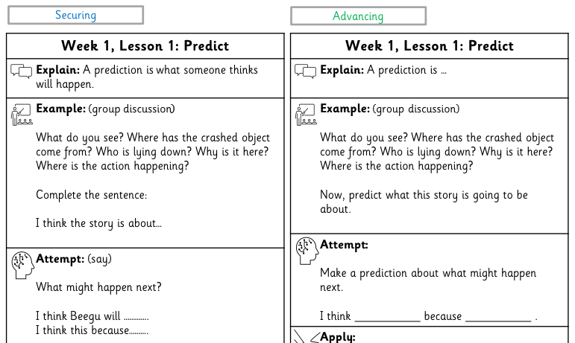

**Reading - Moles**

| **Autumn** | **Spring** | **Summer** |
| --- | --- | --- |
| Beegu  Where the Wild Things Are  The Storm Whale  The Owl and The Pussycat  Aesop’s Fables – The Boy who Cried Wolf | The Tale of Peter Rabbit  Look Up!  Here We Are  Chocolate Cake – Michael Rosen | There’s a Rangtan in My Bedroom  And Tango Makes Three  The Lon Inside  Aesop’s Fables – The Hare and the Tortoise  The Proudest Blue |

*\* Units have been matched up for Year 1 and 2 to allow for progression in writing.*

*\*\* Moles will follow the Year 1 themes but Year 2 will work towards Year 2 objectives (objectives taken from the Y2 blue units).*

**Writing**

| **Autumn** | **Spring** | **Summer** |
| --- | --- | --- |
| * Poetry: pattern and rhyme (Y1) / Poems developing vocabulary (Y2) * Setting descriptions (Y1) / Character descriptions (Y2) * Stories with familiar settings (Y1) / Retelling of a narrative (Y2) * Instructional writing (Y1) / Non-chronological reports (Y2) | * Shape poems and calligrams * Recount from personal experience (Y1 / Recount from personal experience (Y2) * Informal letters (Y1) / formal invitations (Y2) * Poetry on a theme (Y1) / Poetry on a theme - humorous (Y2) * Stories with a familiar setting (Y1) / Stories from other cultures (Y2) * Recount from personal experience B (Y1 / Recount from personal experience B (Y1) | * Poetry: pattern and rhyme B (Y1) / Poems developing vocabulary B (Y2) * Informal letters B (Y1) / formal invitations B (Y2) * Poetry on a theme - nature B (Y1) / Poetry on a theme – humorous B (Y2) * Instructional writing B (Y1) / Non-chronological reports B (Y2) |

*\* EYFS will cover their own curriculum*

*\*\* Years 1 and 2 (in Hedgehogs and Moles) will be following the same curriculum each year to ensure there is no cross over. Knowledge notes will differ to ensure progression and curriculum coverage for KS1 is adhered to – securing and advancing:*

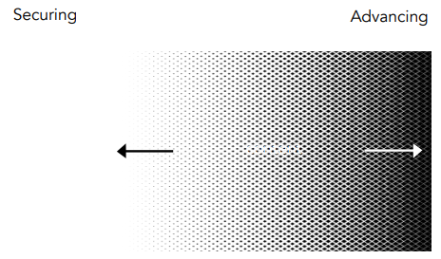*eg,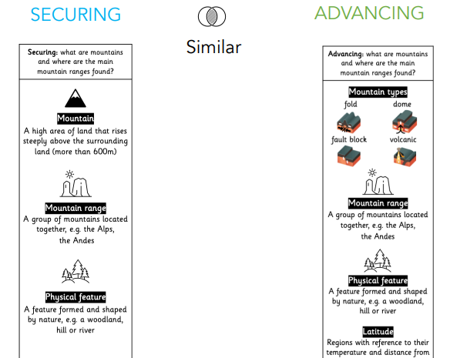*

|  | **Autumn** | | **Spring** | | **Summer** | |
| --- | --- | --- | --- | --- | --- | --- |
| **Science Year 1** | **STRONG START**   * Observation   **INTRODUCE - Seasonal changes & weather**   * What are the four seasons? * What’s the weather like in autumn, winter, spring and summer? * Why does day become night?   **INTRODUCE – Plants, including trees**   * What are the parts of a plant? * What are wild plants and where do you find them? * What are common plants and where do you find them? * What makes a tree? * What trees live around my school? * What’s the difference between trees?   **INTRODUCE - Animals, including humans**   * What is an animal? * What types of animals are there? * What does food tell us about an animal? * What makes me an animal? What senses do I have? | | **REFERNECE LESSON**   * Living things and their habitats   **INTRODUCE - Everyday materials**   * What are materials? * What are things made of in school? * Which materials are waterproof and which are not? * Which materials are transparent and which are opaque? * What’s the best material for the job?   **REVISIT – Plants, including trees**   * What do I remember about plants? * What are the parts of a plant? * What are deciduous and evergreen trees?   **REVIST - Animals, including humans**   * What is an animal? * What types of animals are there? * What does food tell us about an animal? * What makes me an animal? What senses do I have? | | **2ND REVISIT – Plants, including trees**   * What do I remember about plants? * What are the parts of a plant? * What are deciduous and evergreen trees?   **2ND REVSIT - Animals, including humans**   * What is an animal? * What types of animals are there? * What does food tell us about an animal? * What makes me an animal? What senses do I have? | |
| **History** | **STRONG START**   * Chronology   **INTRODUCE – Changes within living memory**   * How have I grown and changed in my life? * What is it like around here? * What are the shops in my community? * What were shops like in the past? * How have shops changed? * How are shops different today than a long time ago? | | **INTRODUCE – The lives of significant people: Mary Anning & David Attenborough**   * Who was Mary Anning? What did she do? * What did Mary Anning discover? * Who was David Attenborough? What did he do? * What has David Attenborough achieved? * What was similar? What was different? | | * **CONTINUE – The lives of significant individuals: Neil Armstrong, Mae Jemison, Bernard Harris Jnr, Tim Peake** * What did these significant people achieve? | |
| **Geography** | **STRONG START**   * Locational knowledge   **Introduce - Continents and oceans UK Countries, cities and seas**   * What are the 7 continents of the world? * What are the 5 oceans of the world? * What are the 4 countries of the UK? * What are the capital cities of the 4 countries of the UK? * What seas surround the UK? | | **Continued - Continents and oceans UK Countries, cities and seas**   * What are the 7 continents of the world? * What are the 5 oceans of the world? * What are the 4 countries of the UK? * What are the capital cities of the 4 countries of the UK? * What seas surround the UK?   **Introduce – Hot and cold places**   * Where is the equator? * Where is hot and where is cold on earth? * Where are the North and South Poles? What are they like? * Where can I find hot countries? What are they like? | | **INTRODUCE – Field and map skills**   * What is a map? * How do I map an imaginary map? * How do I make a real map?   **Continued – Hot and cold places**   * Where is the equator? * Where is hot and where is cold on earth? * Where are the North and South Poles? What are they like? * Where can I find hot countries? What are they like? | |
| **Art and Design** | **Drawing**   * Select appropriate tools Make a range of marks | **Painting**   * Make thick and thin marks Identify shades of primary colours | **Printmaking**   * Apply paint using controlled brushstrokes and stippling * Combine printing techniques such as stencilling and relief printing | **Textiles**   * Combine a range of materials to produce textile art | **3D**   * Select materials based on their properties   Take inspiration from the work of an artist | **Collage**   * Build up layers, using collage to create a background * Tear paper and use scissors to cut for precision |
| **Design and Technology** | **Mechanisms**   * Sliders and levers | **Structures**   * Freestanding structures | **Food and nutrition**   * Preparing fruit and vegetables | **Understanding materials**   * Selecting materials | **Textiles**   * Templates and joining techniques | **Food and nutrition**   * Understanding a recipe |
| **Music** | **Charanga**  Bringing us together | **Nativity**  Singing and performance | **Charanga**  Friendship song | **Easter**  Singing and performance  **Charanga**  Glockenspiel – stage 1 | **Charanga**  The dragon song | **Charanga**  Let your spirit fly |
| **Computing** | **Keychain Computing**   * Computing systems and networks | **Keychain Computing**   * Creating media - digital painting | **Keychain Computing**   * Programming A | **Keychain Computing**   * Creating media - digital writing | **Keychain Computing**   * Grouping data | **Keychain Computing**   * Programming B |
| **PE** | Fundamental Skills | Gymnastics | Dance | Target games | Scooters | Athletics |
| **PSHE** | **Me and my relationships**   * All about me * What makes me special * Me and my special people * Who can help me * My feelings | **Valuing difference**   * I’m special, you’re special * Same and different * Same and different families * Same and different homes * I am caring * I am a friend | **Keeping myself safe**   * What’s safe to go onto my body * What’s safe to go into my body * Safe indoors and outdoors * Listening to my feelings * Keeping safe online * People who help me keep safe | **Rights and responsibility**   * Looking after my special people * Looking after my friends * Being helpful at home and caring for our classroom * Caring for our world * Looking after money | **Being my best**   * Bouncing back when things go wrong * Yes, I can! * Healthy eating * My healthy mind * Move your body * A good night’s sleep | **Growing and changing**   * Seasons * Life stages * Where do babies come from? * Getting bigger * Me and my body – boys and girls |
| **RE**  **Hedgehogs Year A** | ***BIG Question -*** *What does the word ‘God’ mean?*  **Harvest / Creation**  Why is the word ‘God’ so important to Christians?  + know Christians worship God by singing (Y1)  **Muslim – Allah**  Why do Muslims want to whisper “Allah” in a baby’s ear? | | ***BIG Question –*** *Is it always easy to help someone?*  **Lent / Salvation**  How can we help others when they need it?  + Lord’s prayer (Y1)  **Sikh - Courage**  How did Guru Hargobind rescue the 52 princes? | | ***BIG Question -*** *What is really important to do?*  **Creation / Stewardship**  How can we care for our wonderful world?  + Christians pray to and worship God because they believe he is great (Y1)  **Muslim – Tu BiShvat**  Why do Jewish children help plant trees? | |
| **RE**  **Moles Year A** | ***BIG Question –*** *Is it important to belong?* | | ***BIG Question –*** *Why do people celebrate?* | | ***BIG Question –*** *Should everyone learn to pray?* | |
| **Christian - Church**  Why is belonging to God and the church family important to Christians? | **Jewish - Mitzvot**  Why is learning to do good deeds so important to Jewish people? | **Christian - Resurrection**  What are the best symbols of Jesus’ death and resurrection at Easter? | **Hindu - Devotion**  How does a Hindu celebrate devotion to a deity at the festival of Holi? | **Jewish - Tefilla**  Why do Jewish families say so many prayers and blessings? | **Christian - Worship**  Why do Christians pray to God and worship Him? |