Barnham CEVC Primary School Knowledge Organiser
Year 1: Number and Place Value to 10 | Knowledge Organiser
One more and one less
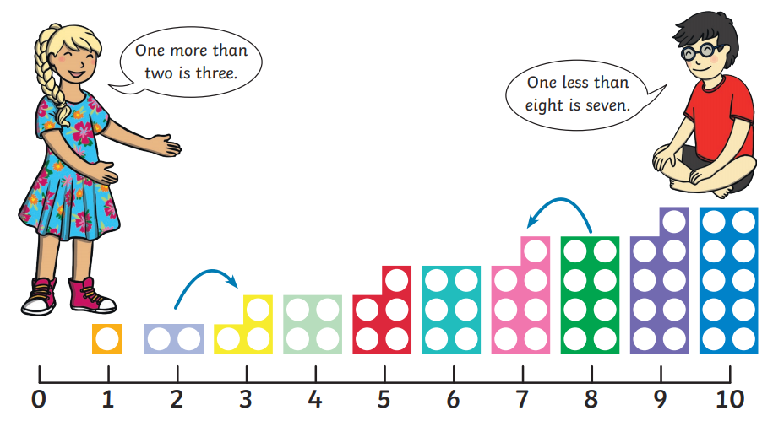

Ordering |  | Comparing
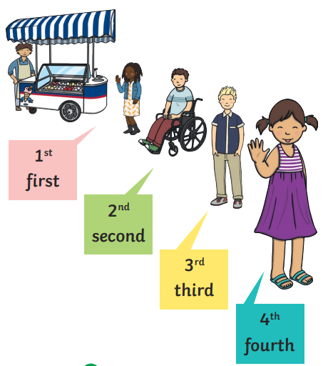 |  | 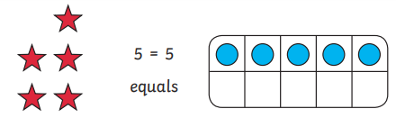
 |  | 
 |  | 
 |  | 

