Barnham CEVC Primary School Knowledge Organiser
Year 1: Addition and Subtraction within 10 | Knowledge Organiser
Counting on and counting back
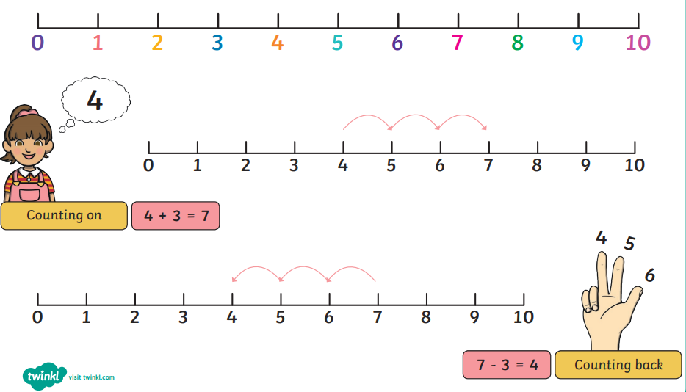

Number Bonds


