Barnham CEVC Primary School Knowledge Organiser
Year 1: Addition and Subtraction within 20 | Knowledge Organiser
Number line
Number bonds
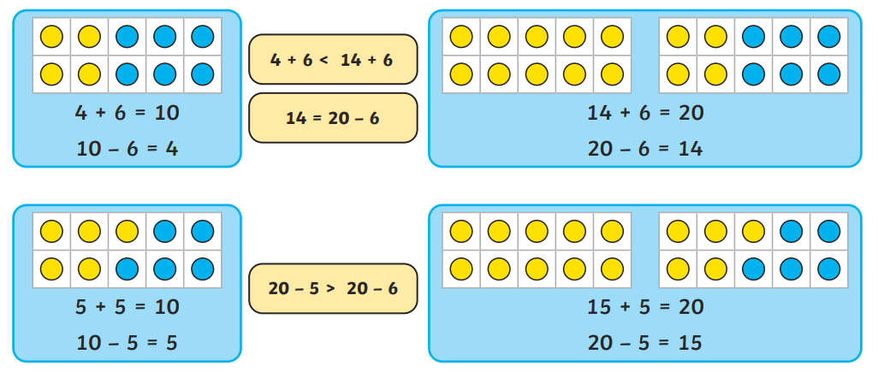
Addition and Subtraction
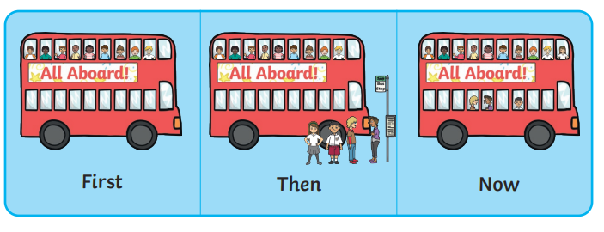  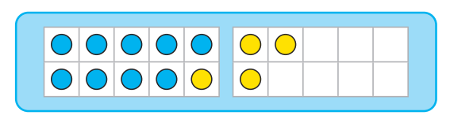  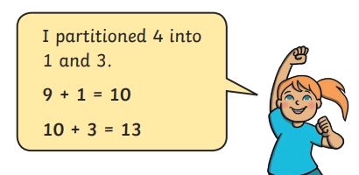 |  | 

