Barnham CEVC Primary School Knowledge Organiser
Year 1: Number and Place Value to 50 | Knowledge Organiser
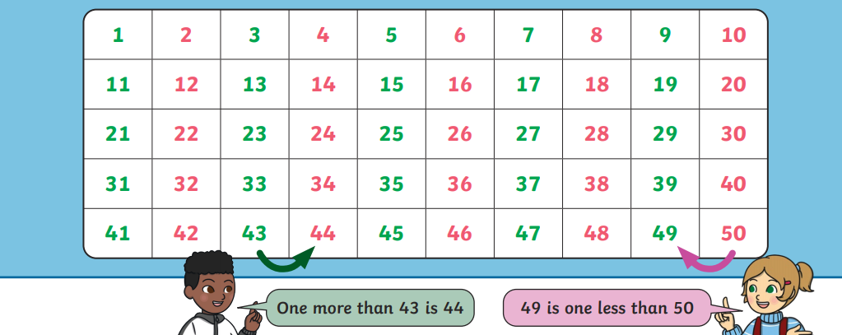
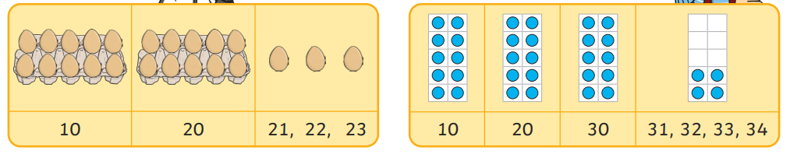
Counting in 5s
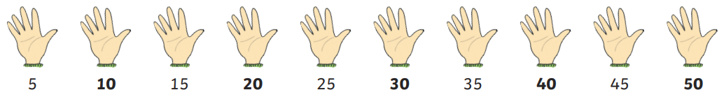
Comparing numbers


