Barnham CEVC Primary School Knowledge Organiser
Year 1: Length and Height | Knowledge Organiser
Height |  | Length
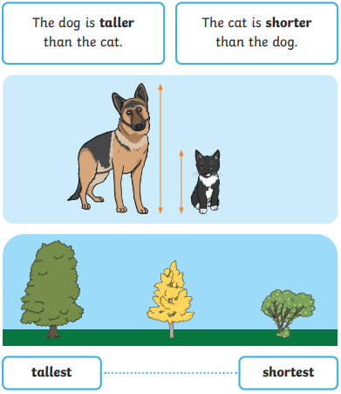 |  | 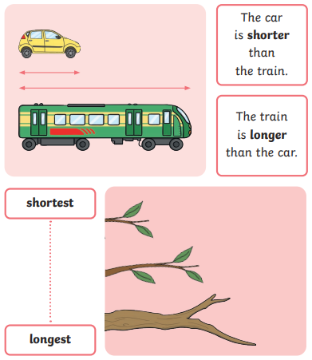
Length and Height


