Barnham CEVC Primary School Knowledge Organiser
Year 1: Weight and Volume | Knowledge Organiser
Weight and Mass
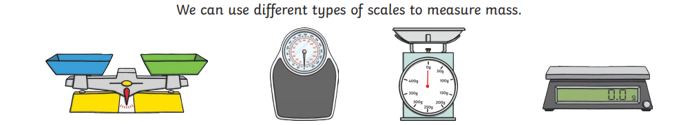

Compare Mass |  |  | Measure Mass
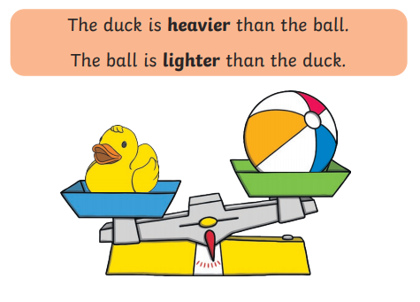 |  |  | 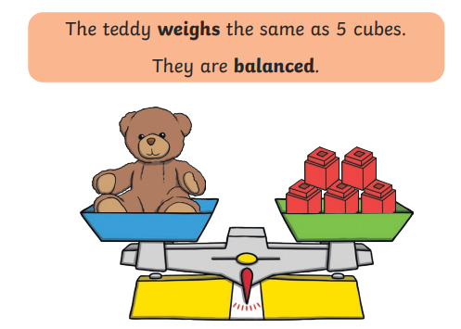
Capacity and Volume
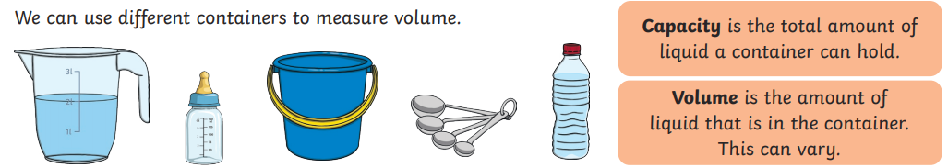

Measure Capacity |  | Compare Capacity
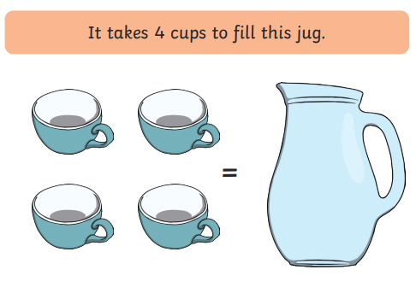 |  | 

