Barnham CEVC Primary School Knowledge Organiser
Year 1: Multiplication and Division |  | Knowledge Organiser
Count in 2s |  |  |  | Make equal groups
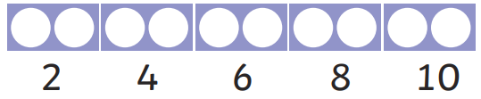 |  |  |  | 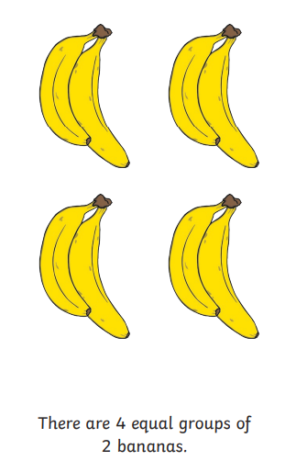
Count in 5s
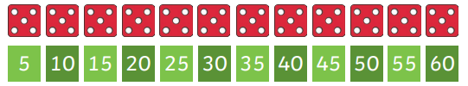
Count in 10s
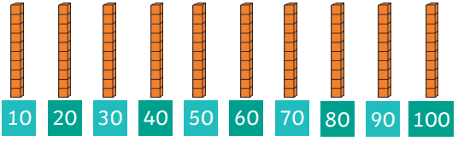
Add equal groups | Make arrays |  |  |  | Make doubles
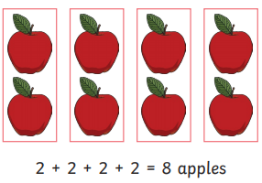 | 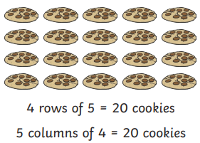 |  |  |  | 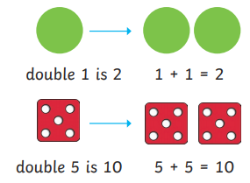
Group Equally |  |  | Share Equally
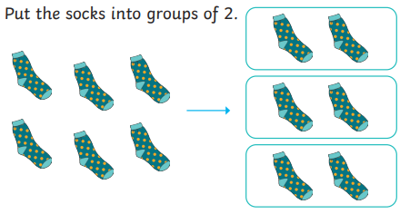 |  |  | 

