Barnham CEVC Primary School Knowledge Organiser
Year 2: Number and Place Value |  | Knowledge Organiser
Key Vocabulary | 2 digit numbers |  | Compare numbers
hundreds  tens  ones  zero  place value  greater than  less than  order  more  less  partition  digit | 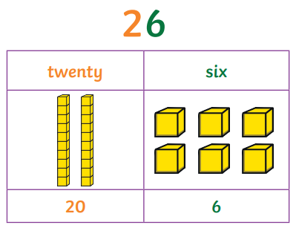 |  | 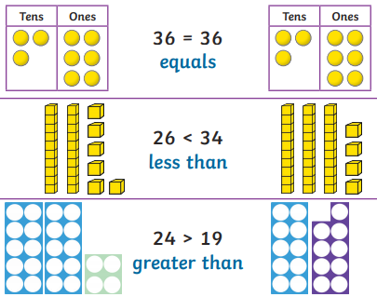
 | Counting |  | Order numbers
 | 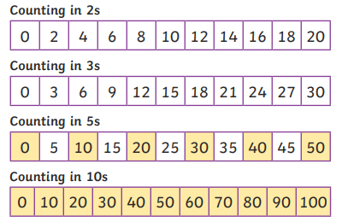 |  | 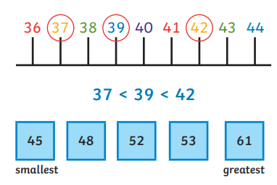
Read, write and represent numbers to 100


