Barnham CEVC Primary School Knowledge Organiser
Year 2: Addition and Subtraction |  | Knowledge Organiser
Key Vocabulary | Addition and Subtraction Bonds to 20
add  total  plus  make  sum  more  altogether  difference  subtract  less  minus  take away  column addition  column subtraction  place value  exchange  mentally/orally  inverse  number facts | 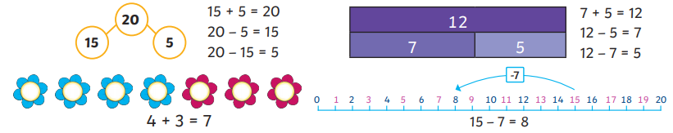
 | Methods
 | 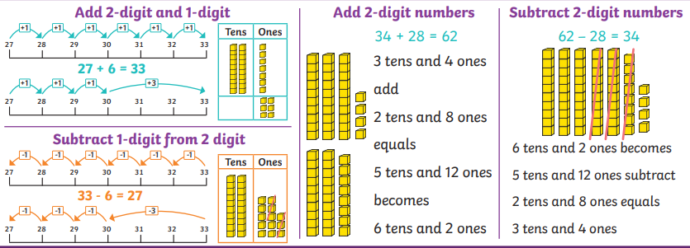
 | Addition and Subtraction Bonds to 100
Mental Methods |  |  | More or less / add and subtract 1s and 10s
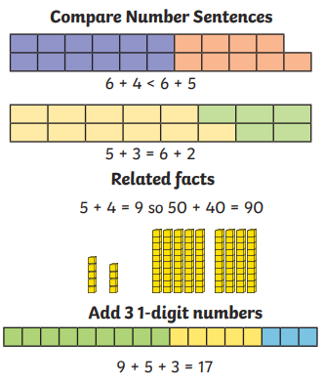 |  |  | 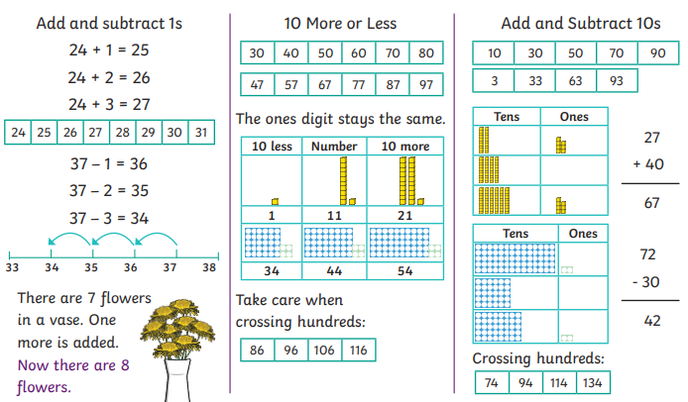
Check Calculations


