Barnham CEVC Primary School Knowledge Organiser
Year 2: Multiplication and Division |  | Knowledge Organiser
Key Vocabulary | Recognise equal groups |  |  | Make equal groups
groups  equal groups  lots of  arrays  repeated addition  multiplication  multiply  times tables | 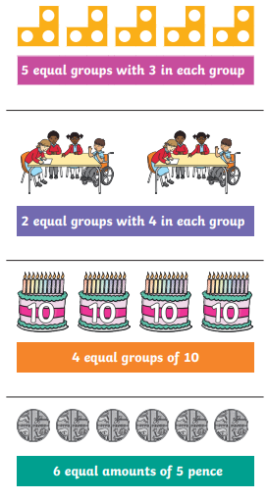 |  |  | 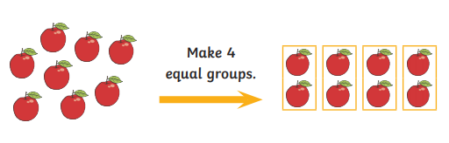
 |  |  |  | Add equal groups
 |  |  |  | 
 |  |  |  | The multiplication symbol
 |  |  |  | 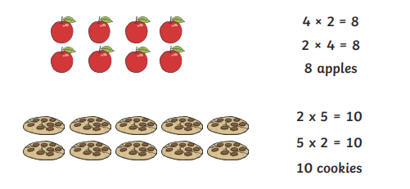
Multiplication from pictures |  |  | The 2 Times Tables
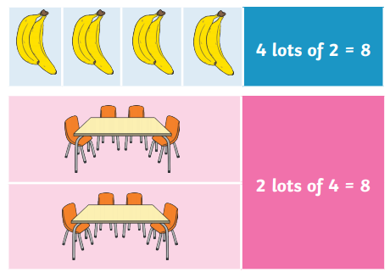 |  |  | 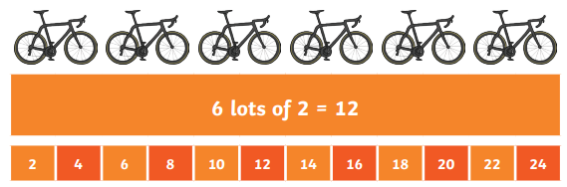
 |  |  | The 5 Times Tables
 |  |  | 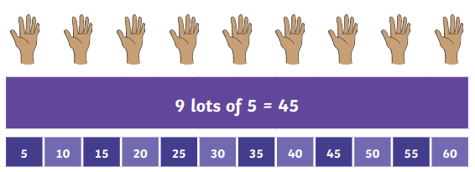
Use arrays |  |  | The 10 Times Tables
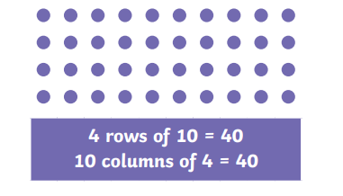 |  |  | 

