Barnham CEVC Primary School Knowledge Organiser
Year 2: Statistics |  | Knowledge Organiser
Key Vocabulary | Tally Charts |  |  | Block Diagrams
data  interpret  key  tally  pictogram  block diagram  table  total  compare  symbol | 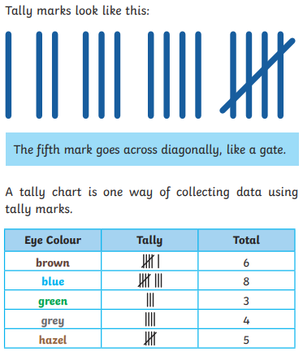 |  |  | 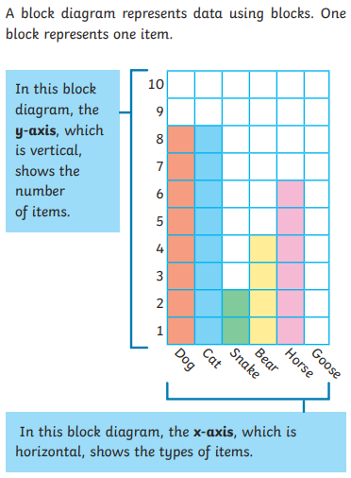
Pictograms
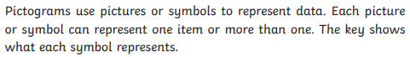 |  |  | 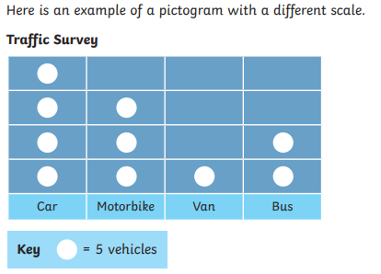
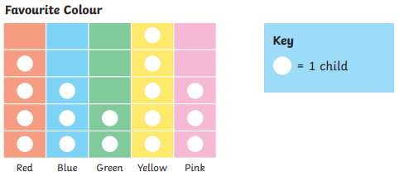
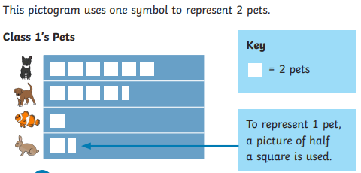 |  |  | 

