Barnham CEVC Primary School Knowledge Organiser
Year 2: Properties of Shape |  | Knowledge Organiser
Key Vocabulary | Recognise and describe 2D shapes |  |  | Recognise and describe 3D shapes
2D and 3D  flat  solid  corner  vertex  vertices  apex  side  edge  face  curved  straight  round  line of symmetry  vertical  pattern | 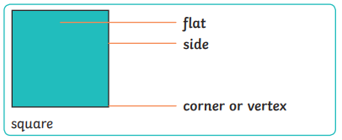  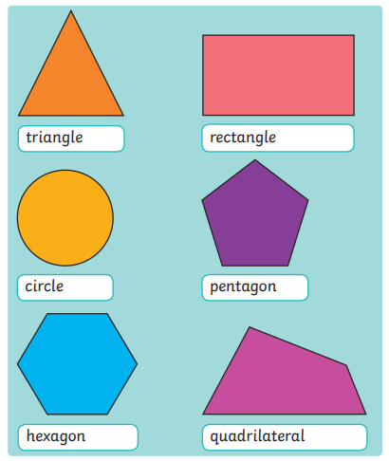 |  |  | 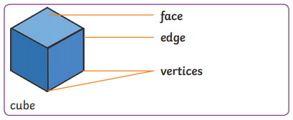  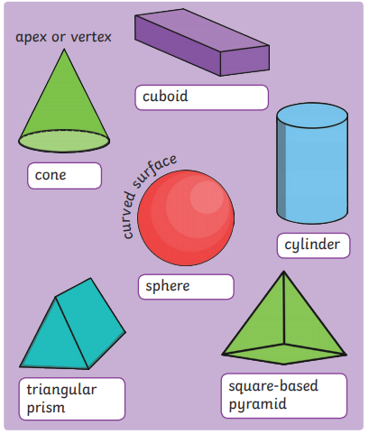
Lines of Symmetry |  |  | Repeating Shape Patterns
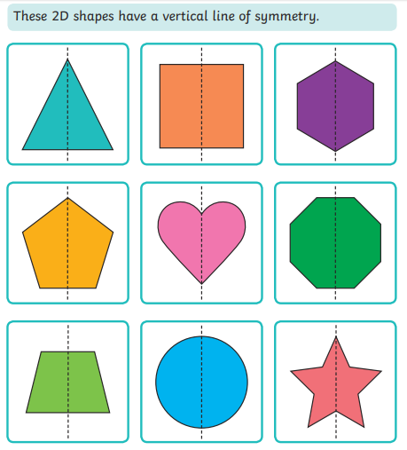 |  |  | 

