Barnham CEVC Primary School Knowledge Organiser
Year 2: Fractions |  | Knowledge Organiser
Key Vocabulary | Recognising Unit Fractions
fraction  part  whole  equal  share  half  quarter  thirds  equivalent  numerator  denominator | 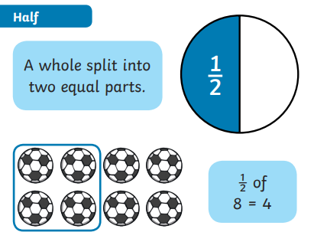 |  |  | 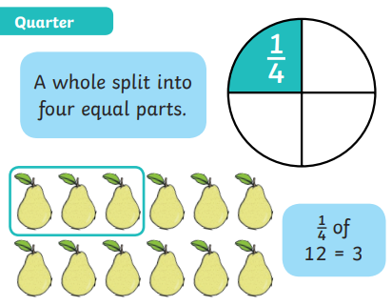
 | 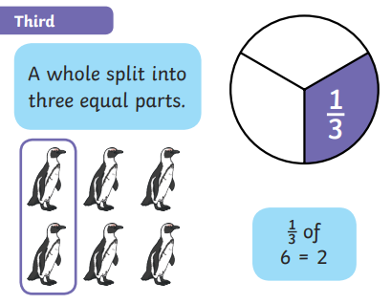 |  |  | 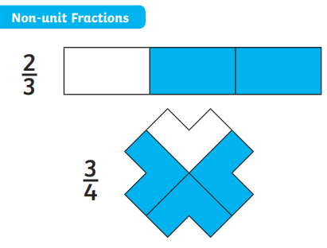
Equivalent Fractions |  |  | Counting in Fractions
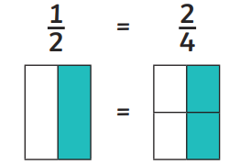 |  |  | 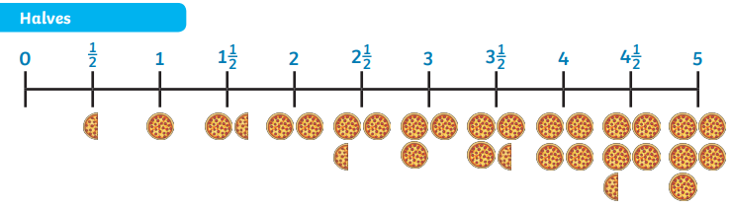
Numerator and Denominator |  |  | 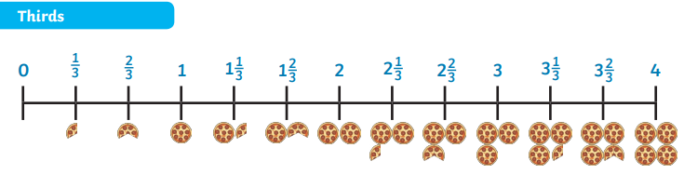
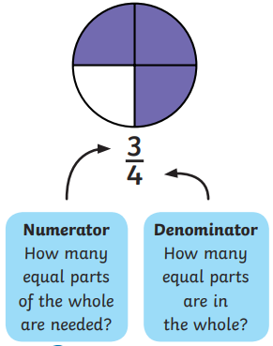
 |  |  | 

