Barnham CEVC Primary School Knowledge Organiser
Year 2: Length and Height |  | Knowledge Organiser
Key Vocabulary | Measuring in Centimetres
length  long  short  height  tall  measure  ruler  tape measure  metre stick  centimetres (cm)  metres (m)  compare  order | 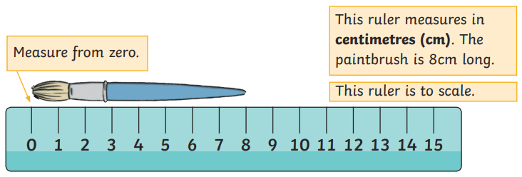
 | Measuring in Metres
 | 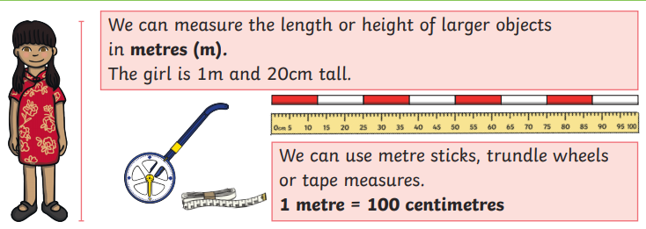
Compare Height |  |  | Ordering Length
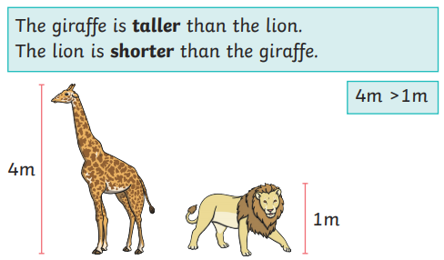 |  |  | 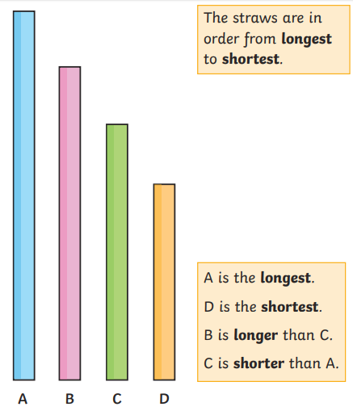
Comparing Length


