Barnham CEVC Primary School Knowledge Organiser
Year 2: Position and Direction |  | Knowledge Organiser
Key Vocabulary | Describing straight line movement
forwards  backwards  left  right  north  south  east  west  quarter turn  half turn  three-quarter turn  clockwise  anticlockwise  pattern  sequence | 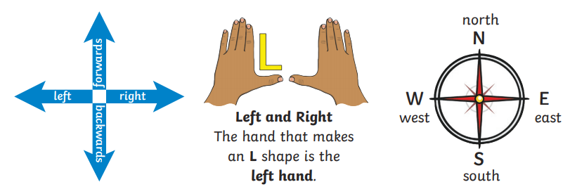
 | Describing turns
 | 

