Barnham CEVC Primary School Knowledge Organiser
Year 2: Time |  | Knowledge Organiser
Key Vocabulary | O’clock and Half Past
time  clock  hours  minutes  hands  o’clock  half past  quarter past  quarter to  five minutes  duration  shorter  longer  hour hand  minute hand | 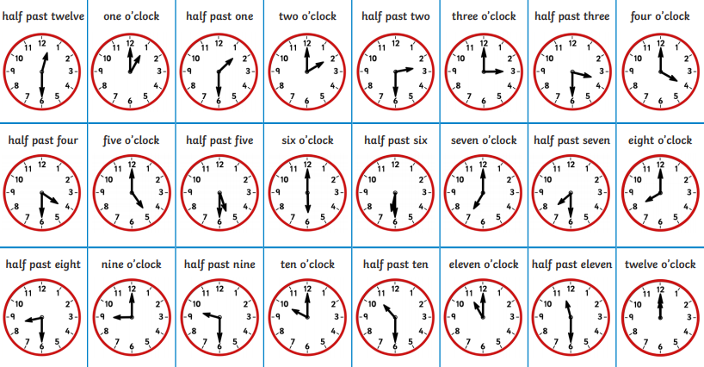
 | Past and to
 | 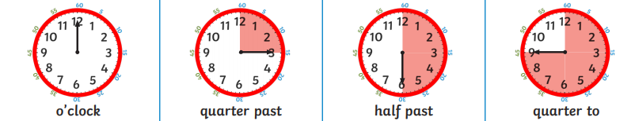
Telling time to 5 minutes |  |  | O’clock and Half Past | Find durations of time
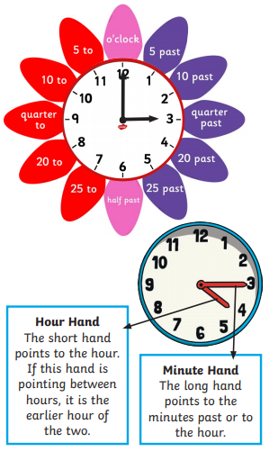 |  |  | 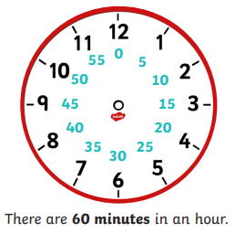  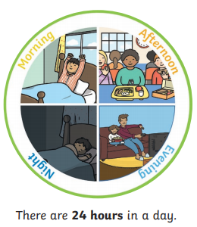 | 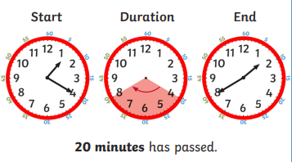
 |  |  |  | Compare duration of time
 |  |  |  | 

