Barnham CEVC Primary School Knowledge Organiser
Year 2: Mass, Capacity and Temperature |  | Knowledge Organiser
Key Vocabulary | Mass
mass  gram (g)  kilogram (kg)  lighter  heavier  capacity  volume  millilitre (ml)  litre (l)  temperature  Celsius  degrees | 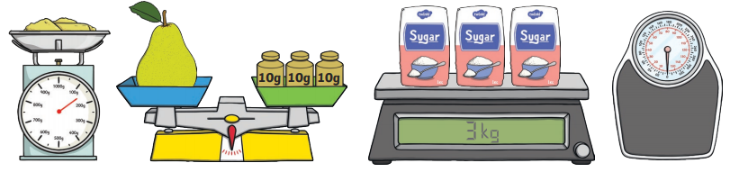  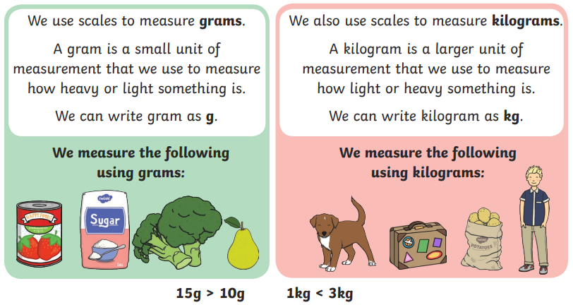
Capacity |  |  | Temperature
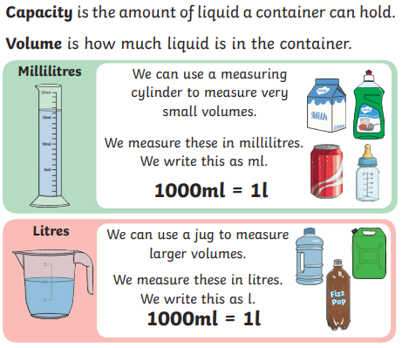  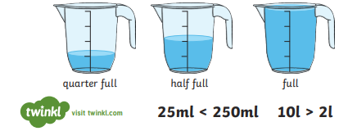 |  |  | 

