Barnham CEVC Primary School Knowledge Organiser
Year 3: Number and Place Value |  | Knowledge Organiser
Key Vocabulary | 3 digit numbers |  |  | 10 or 100 more or less
hundreds  tens  ones  zero  place value  greater than  less than  order  more  less  partition  digit | 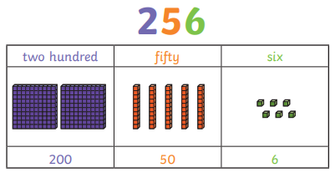 |  |  | 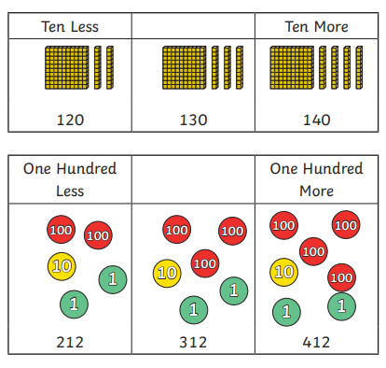
 | Counting in 4s and 8s
 | 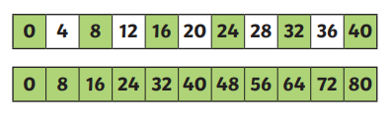
 | Counting in 50s and 100s
 | 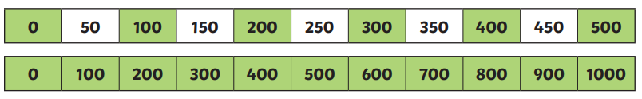
Compare and order |  |  | Represent numbers to 1000
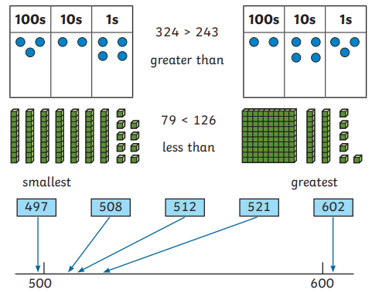 |  |  | 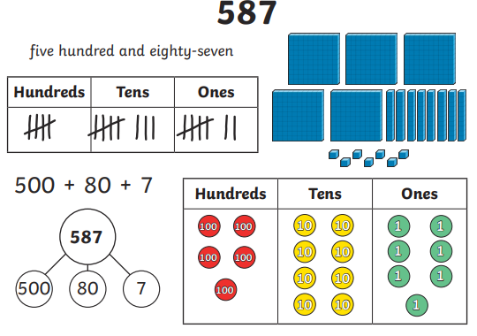
Numerals and word to 1000


