Barnham CEVC Primary School Knowledge Organiser
Year 3: Addition and Subtraction |  | Knowledge Organiser
Key Vocabulary | Addition and Subtraction methods
add  total  plus  make  sum  more  altogether  difference  subtract  less  minus  take away  change  column addition  column subtraction  place value  exchange  regroup  mentally/orally  inverse  number facts | 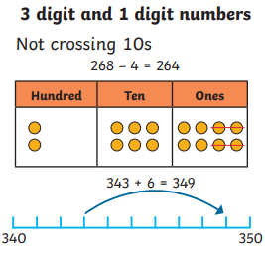  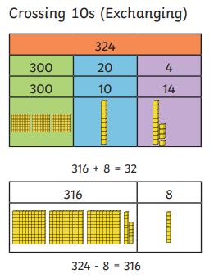 |  | 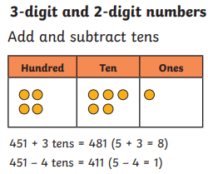  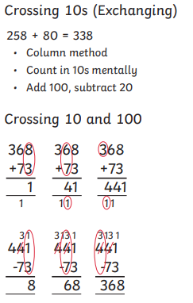 |  | 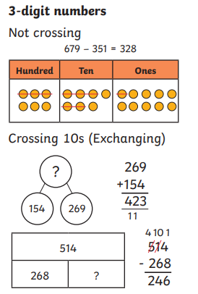  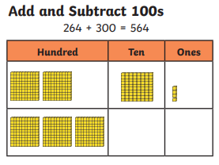
Estimate |  |  |  | Check answers
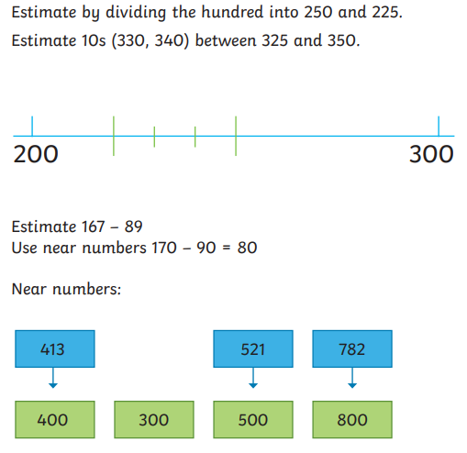 |  |  |  | 

