Barnham CEVC Primary School Knowledge Organiser
Year 3: Multiplication and Division |  | Knowledge Organiser
Key Vocabulary | Multiplication and division facts (3, 4 and 8 multiplication tables)
time table  multiply by  divide by  array  fact families  regrouping  place value  exchange  times  multiply  lots of  groups of  divide  share  remainder | 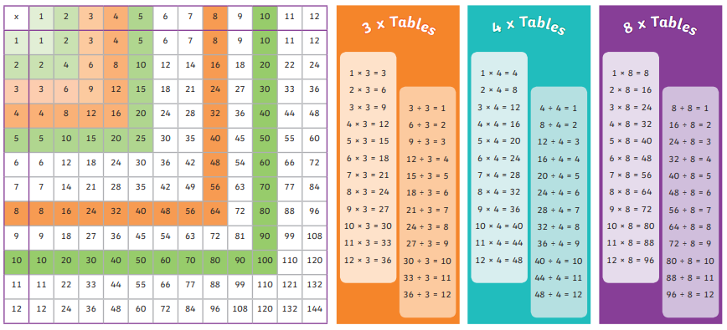
 | Write and calculate mathematical statements |  |  | Related calculations
 | 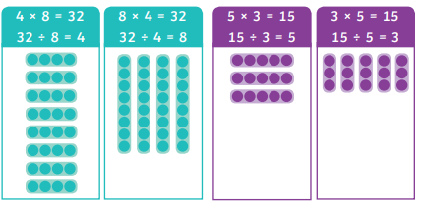 |  |  | 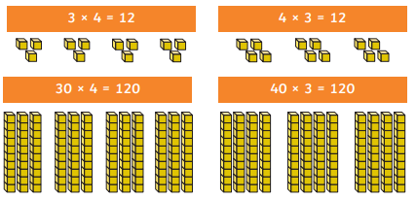
Written methods for multiplication – no regrouping |  |  | Written multiplication methods – with regrouping
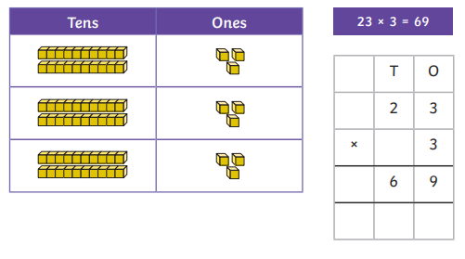 |  |  | 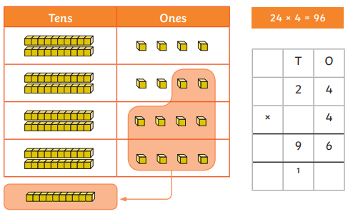
Written dividion methods – no regrouping |  |  | Written division methods – with regrouping
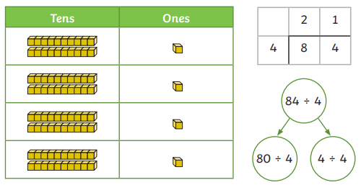 |  |  | 

