Barnham CEVC Primary School Knowledge Organiser
Year 3: Money |  | Knowledge Organiser
Key Vocabulary | UK Coins
amount  change  coin  combinations  convert  note  pence  penny  pounds  value | 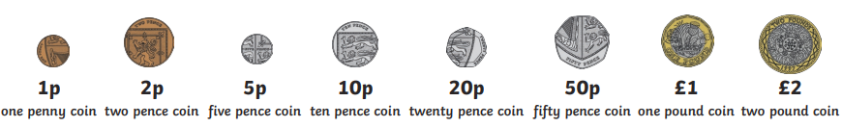
 | UK Notes
 | 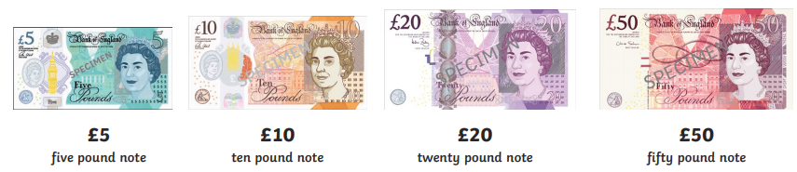
 | Pounds and Pence |  |  |  | Convert Pounds and Pence
 | 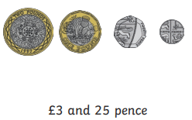 |  | 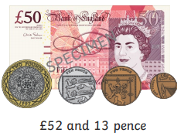 |  | 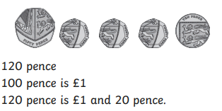
Adding Amounts
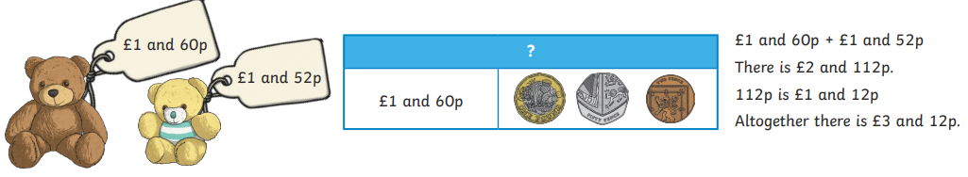

Subtracting Amounts |  |  |  | Giving Change
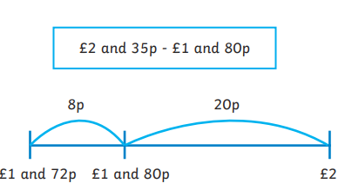 |  |  |  | 

