Barnham CEVC Primary School Knowledge Organiser
Year 3: Statistics |  | Knowledge Organiser
Key Vocabulary | Bar Charts
data  pictogram  symbol  bar chart  horizontal axis  vertical axis  axes  scale  intervals  table  interpret  read  How many more  bar model | 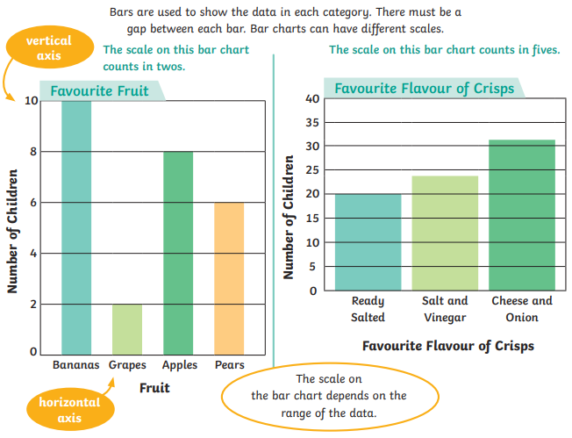
Tables |  |  | Pictograms
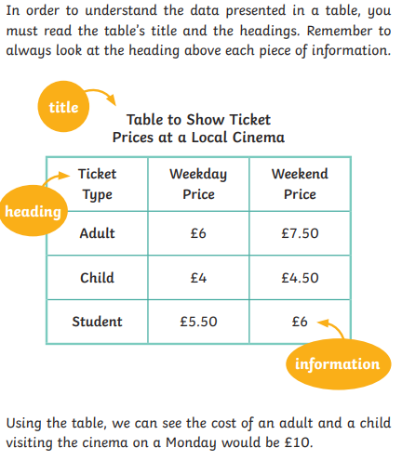 |  |  | 

