Barnham CEVC Primary School Knowledge Organiser
Year 3: Length and Perimeter |  | Knowledge Organiser
Key Vocabulary | Measure Length
metre (m)  centimetres (cm)  millimetres (mm)  height  length  width  perimeter  further/furthest  high/highest  longer/longest  shorter/shortest  taller/tallest  equivalent  convert  compare | 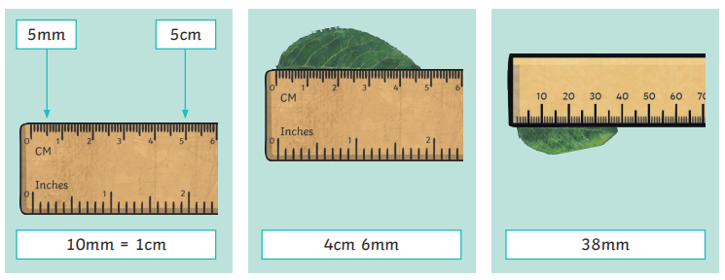
 | Equivalent Length
 | 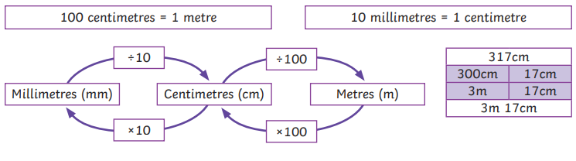
Compare Lengths |  |  | Add and Subtract Lengths
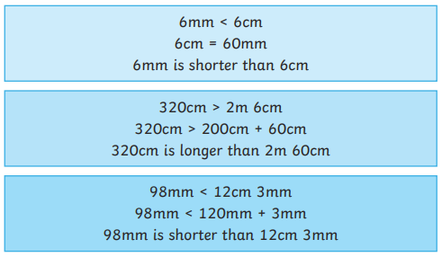 |  |  | 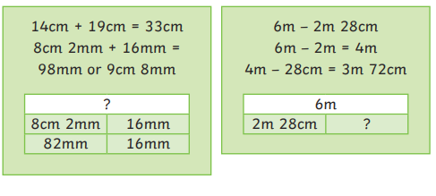
Perimeter


