Barnham CEVC Primary School Knowledge Organiser
Year 3: Fractions |  |  | Knowledge Organiser
Key Vocabulary | Recognising Fractions |  |  |  | Comparing Fractions
numerator  denominator  unit fraction  non-unit fraction  equivalent  compare  order  halves  thirds  quarters  fifths  sixths  eighths  tenths  decimal tenths  bar model | 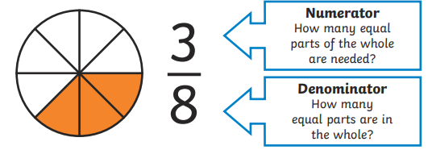 |  |  |  | 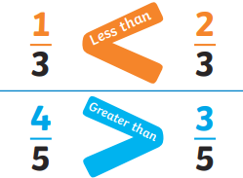
 | Equivalent Fractions
 | 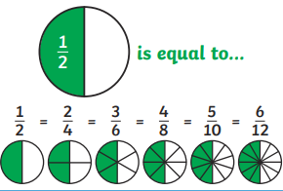 |  |  | 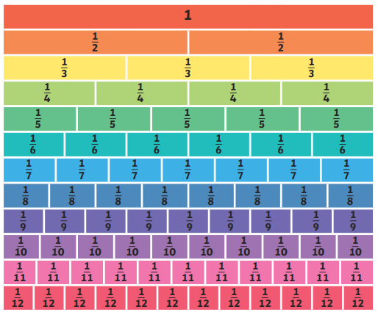
 | 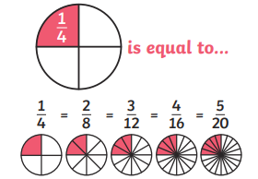
Add and Subtract Fratcions |  | Tenths
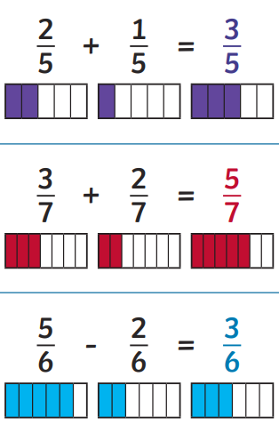 |  | 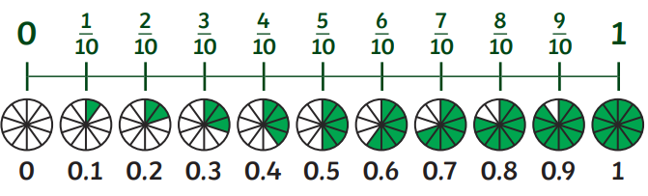
 |  | Fractions of Amounts
 |  | 

