Barnham CEVC Primary School Knowledge Organiser
Year 3: Time |  | Knowledge Organiser
Key Vocabulary | Analogue and Digital clocks
12-hour time  24-hour time  roman numerals  analogue clock  digital clock  hours  minutes  seconds  o’clock  half past  quarter past  quarter to  midday  midnight  noon | 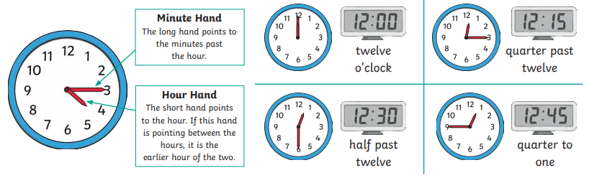
 | Time and Roman Numerals |  | Hours, Minutes and Seconds
 | 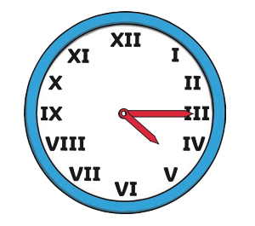 |  | 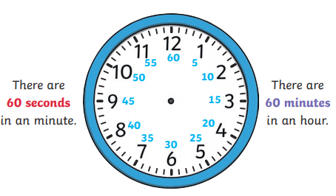
24-hour time |  |  |  | Calculate durations of time
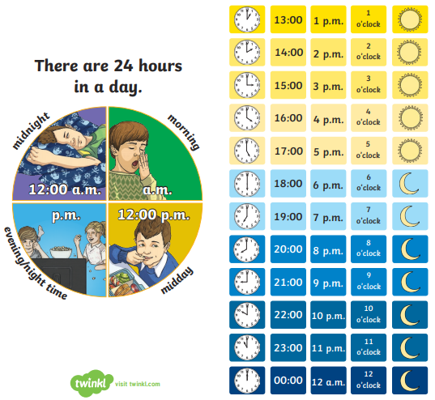 |  |  |  | 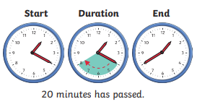
 |  |  |  | Compare durations of time
 |  |  |  | 

