Barnham CEVC Primary School Knowledge Organiser
Year 3: Properties of Shape |  | Knowledge Organiser
Key Vocabulary | Turns and Angles
quarter turn  half turn  three-quarter turn  angle  right angle  acute  obtuse  horizontal  vertical  parallel  perpendicular  polygon  2D/3D  flat face  curved face  edge  curved edge  vertex  vertices  apex | 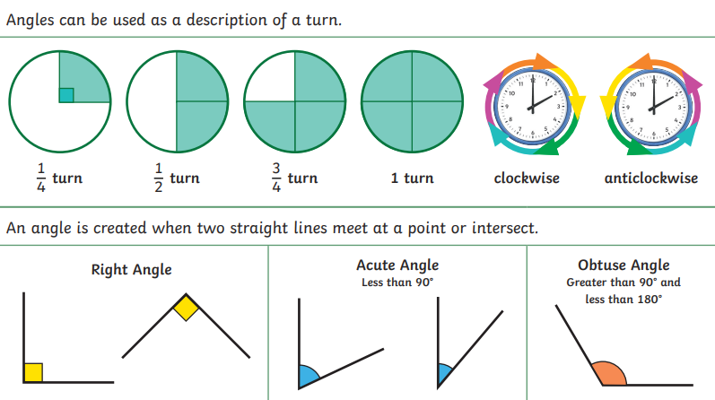
 | Types of Lines
 | 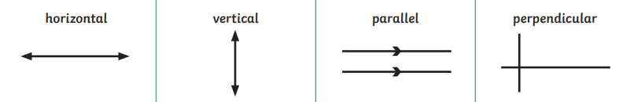
Recognise and describe 2D shapes |  |  | Recognise and describe 3D shapes
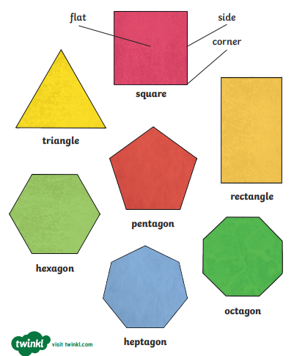 |  |  | 

