Barnham CEVC Primary School Knowledge Organiser
Year 3: Mass and Capacity |  | Knowledge Organiser
Key Vocabulary | Measure and compare mass
mass  gram  kilogram  capacity  volume  millilitre  litre  lighter  heavier  add  subtract  compare  scales  convert | 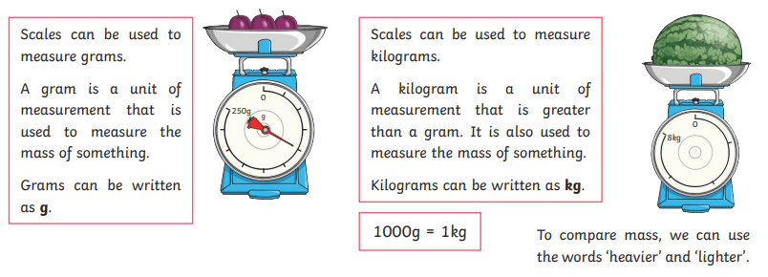
 | Measure and compare capacity
 | 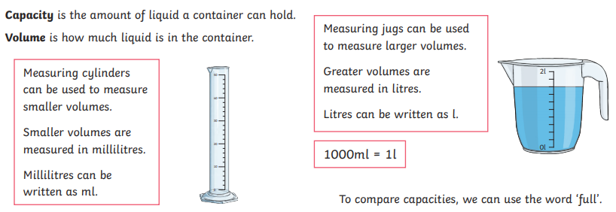
Mass (reading scales) |  |  | Capacity (reading scales)
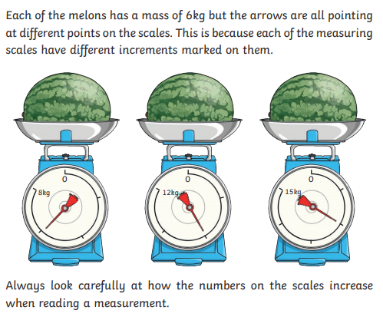 |  |  | 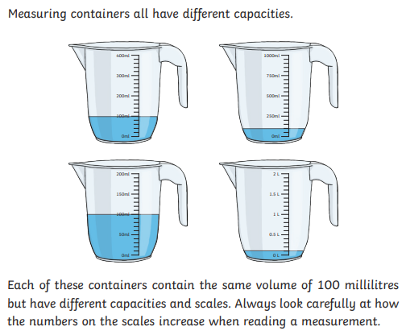
Add and subtract mass |  |  | Add and subtract capacity
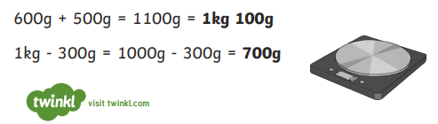 |  |  | 

