Barnham CEVC Primary School Knowledge Organiser
Year 4: Number and Place Value |  | Knowledge Organiser
Key Vocabulary | Counting
thousands  hundreds  tens  ones  zero  place value  greater than  less than  order  round  rounded  negative number  partition  digit  roman numeral | 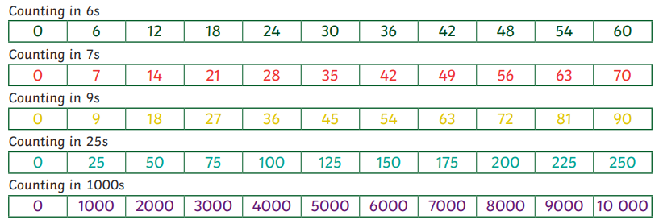
 | Order and compare |  |  | 1000 more or 1000 less
 | 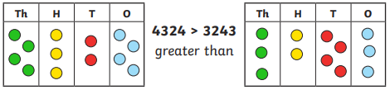 |  |  | 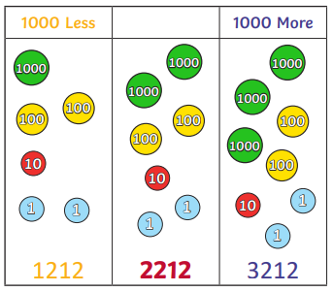
 | 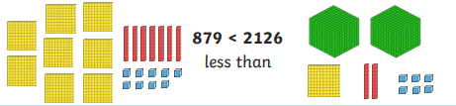
 | 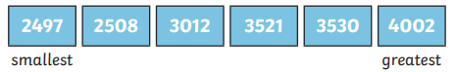
Negative numbers
Represent 4 digit numbers |  |  | Roman numerals
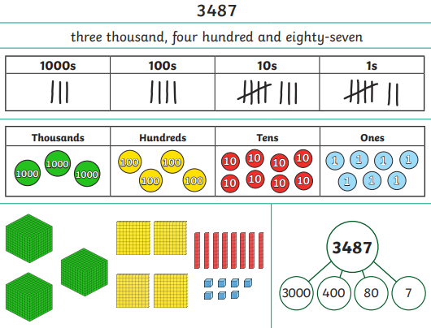 |  |  | 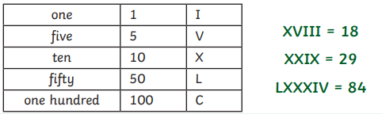
 |  |  | Rounding
 |  |  | 

