Barnham CEVC Primary School Knowledge Organiser
Year 4: Addition and Subtraction |  | Knowledge Organiser
Key Vocabulary | Addition and Subtraction methods
add  total  plus  make  sum  more  altogether  difference  subtract  less  minus  take away  change  column addition  column subtraction  inverse operation  number facts  place value  exchange  regroup  mentally/orally | 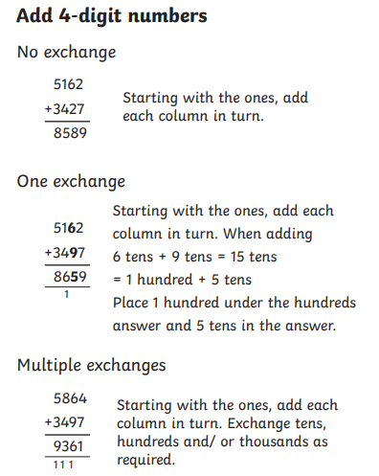 |  |  | 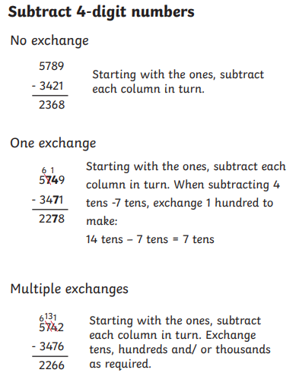
 | Efficient Subtraction
Add and Subtract 1s, 10s, 100s and 1000s |  |  | Round to Estimate
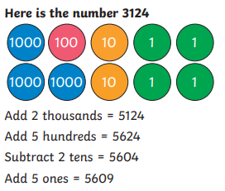  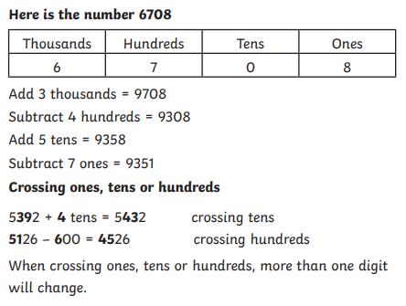 |  |  | 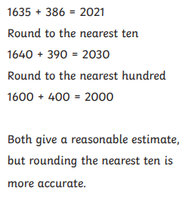 |  | 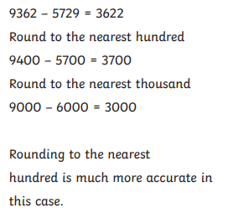
 |  |  | Checking Strategies
 |  |  | 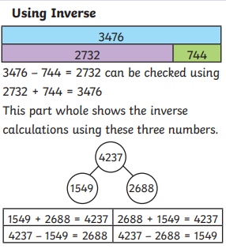 |  | 

