Barnham CEVC Primary School Knowledge Organiser
Year 4: Area and Perimeter |  | Knowledge Organiser
Key Vocabulary | Area and perimeter |  | Measuring area
area  perimeter  centimetres  metres  squares  distance  millimetres  kilometres  length  width  rectilinear  right angle | 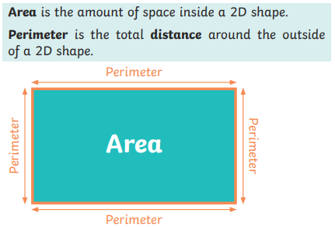 |  | 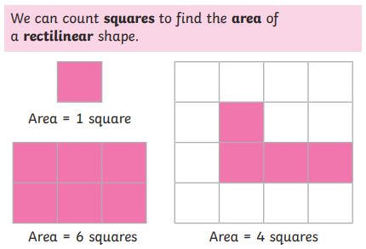
 | Units of measure for perimeter |  | Rectilinear figures
 | 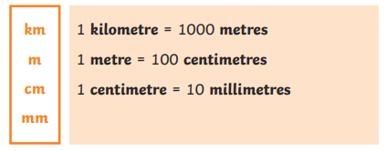  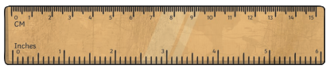 |  | 

