Barnham CEVC Primary School Knowledge Organiser
Year 4: Multiplication and Division |  | Knowledge Organiser
Key Vocabulary | Multiplication and division facts |  |  |  | Use place value and multiply and divide mentally.
multiply  groups of  lots of  times  place value  regroup  exchange  divide  share  remainder  factor  multiple  product | 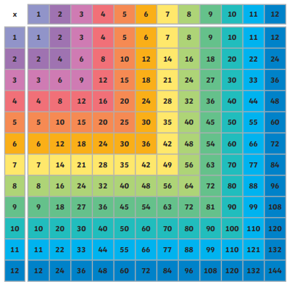 |  |  |  | 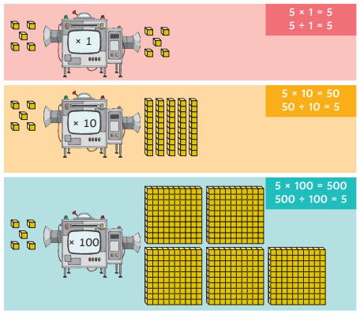
 | Factor pairs and commutativity |  |  | Multiplying using the written formal method
 | 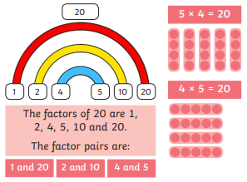 |  |  | 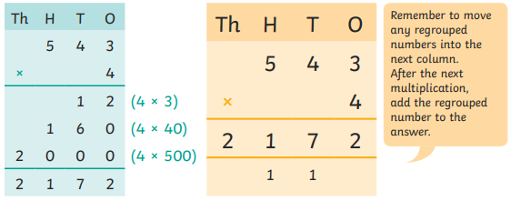
Mental calculations for solving problems |  |  | Integer scaling problems
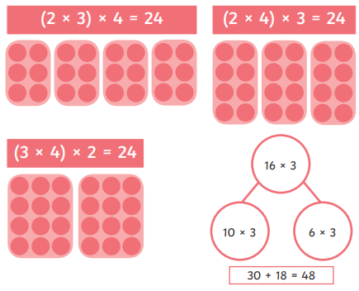 |  |  | 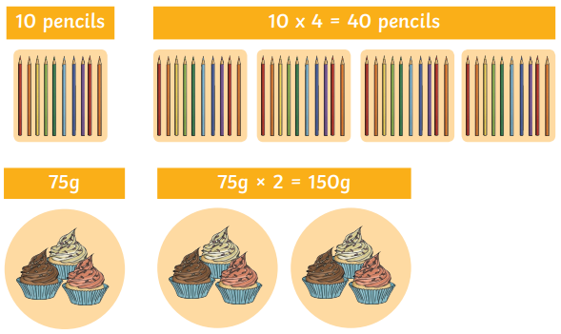
Short division with exact answers


