Barnham CEVC Primary School Knowledge Organiser
Year 4: Fractions |  | Knowledge Organiser
Key Vocabulary | Fraction families
numerator  denominator  non-unit fraction  unit fraction  equivalent  quantities  whole  halves  thirds  quarters  fifths  sixths  sevenths  eighths  ninths  tenths  elevenths  twelfths  simplify  common denominator | 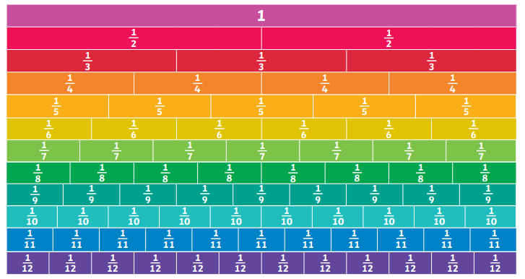
 | Fraction of quantities
 | 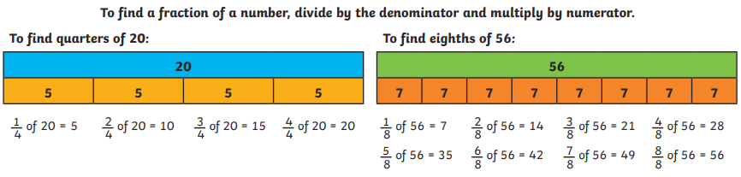
Adding fractions |  |  | Subtracting fractions
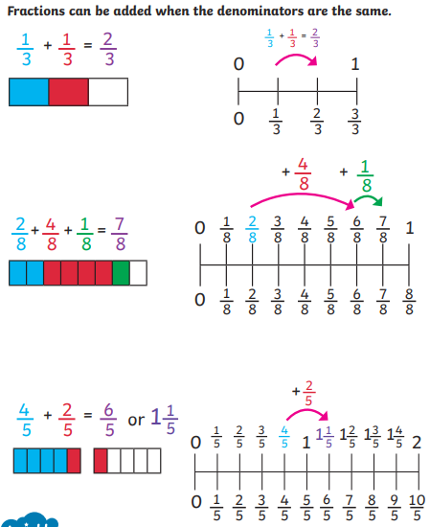 |  |  | 

