Barnham CEVC Primary School Knowledge Organiser
Year 4: Decimals |  |  | Knowledge Organiser
Key Vocabulary | Tenths and hundredths |  |  | Fraction and decimal equivalents
tenths  hundredths  decimal tenths  decimal hundredths  decimal equivalence  part-whole model  rounding  decimal point  place value  1dp.  2dp. | 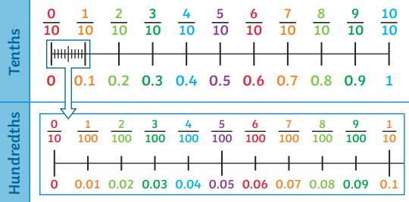 |  |  | 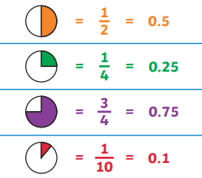
 | Tenths and hundredths decimals equivalence
 | 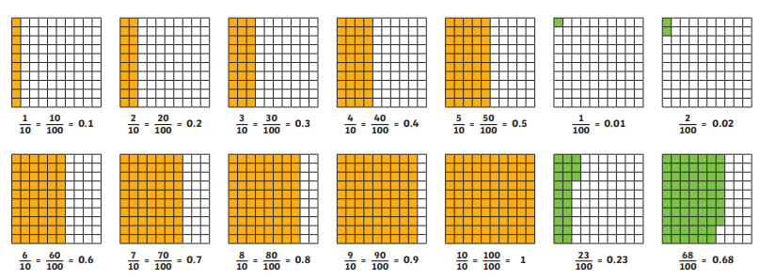
Dividing by 10 |  | Rounding decimals
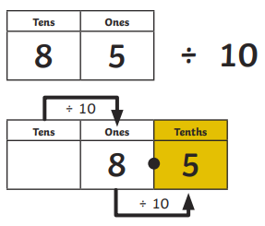 |  | 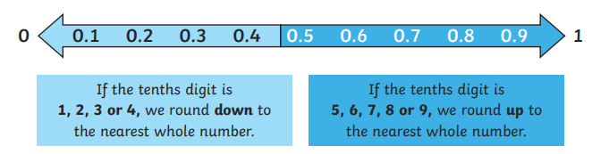
Dividing by 100 |  | Make a whole |  |  | Comparing decimal numbers with 2dp.
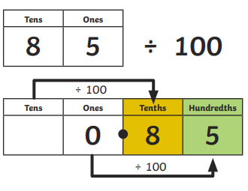 |  | 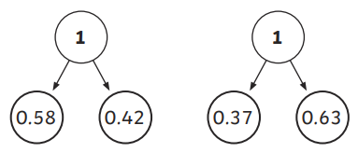 |  |  | 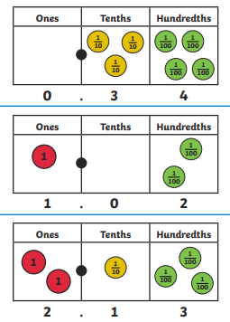
 |  | Partitioning
 |  | 

