Barnham CEVC Primary School Knowledge Organiser
Year 4: Time |  | Knowledge Organiser
Key Vocabulary | Analogue and digital clocks
12-hour time  24-hour time  roman numerals  analogue clock  digital clock  hours  minutes  seconds  o’clock  half past  quarter past  quarter to  midday  midnight  noon  fortnight  am  pm | 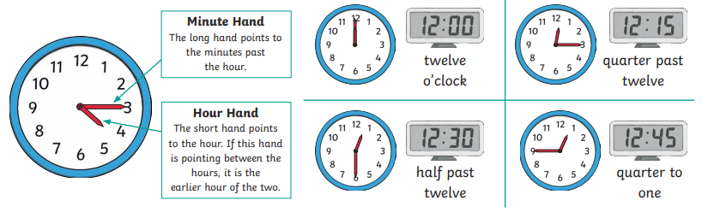
 | Durations of time
 | 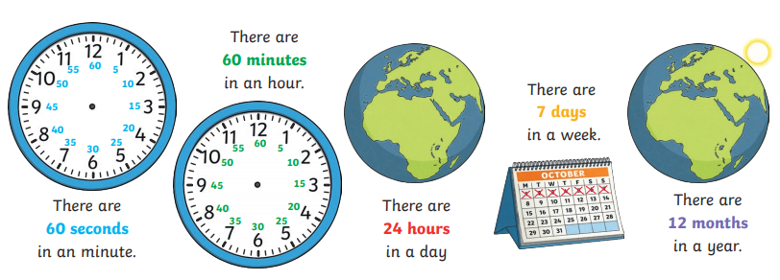
24-hour time


