Barnham CEVC Primary School Knowledge Organiser
Year 4: Statistics |  | Knowledge Organiser
Key Vocabulary | Discrete and continuous data |  |  | Bar charts
bar chart  pictogram  frequency table  tally chart  discrete data  continuous data  time graph  sum  difference  comparison  interpret  how many more  difference  bar model | 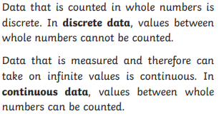 |  |  | 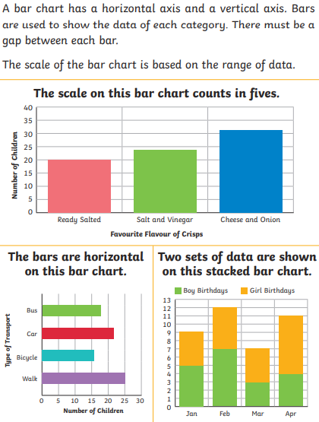
 | Frequency tables
 | 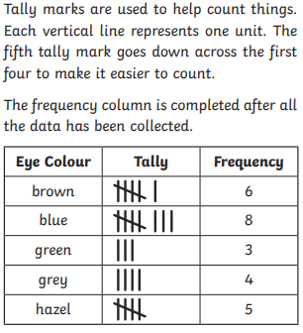
Time graphs |  |  | Pictograms
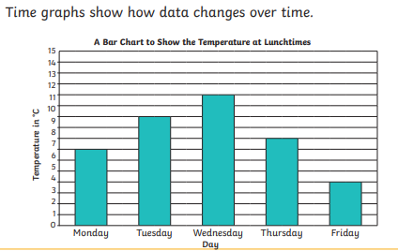 |  |  | 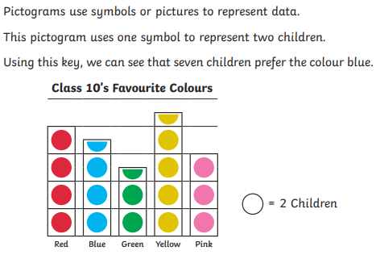
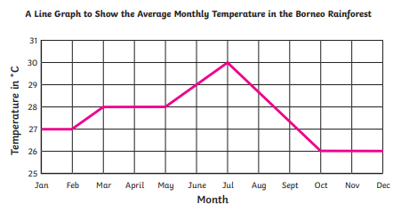 |  |  | 

