Barnham CEVC Primary School Knowledge Organiser
Year 4: Properties of Shape |  | Knowledge Organiser
Key Vocabulary | Triangles |  |  | Quadrilaterals
angle  right angle  acute  obtuse  horizontal  vertical  diagonal  parallel  perpendicular  2D  polygon  line of symmetry  reflection  mirror line  isosceles  equilateral  scalene  quadrilateral  rhombus  parallelogram  trapezium | 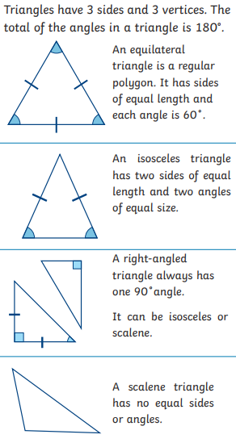 |  |  | 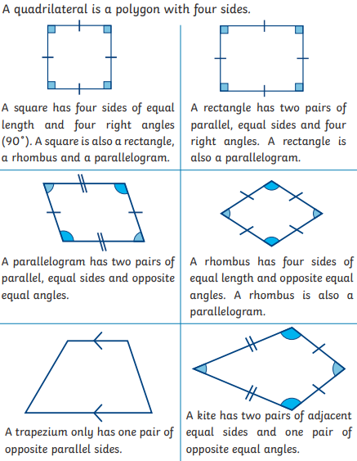
Angles |  |  | Lines of symmetry
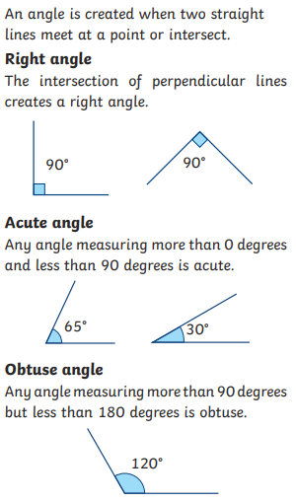 |  |  | 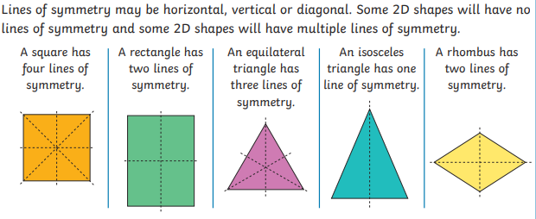
 |  |  | Symmetric figures
 |  |  | 

