Barnham CEVC Primary School Knowledge Organiser
Year 5: Number and Place Value |  | Knowledge Organiser
Key Vocabulary | Compare and Order
millions  thousands  hundreds  tens  ones  zero  place value  greater than  less than  order  round  rounded  negative number  partition  digit  interval  sequence  linear sequence | 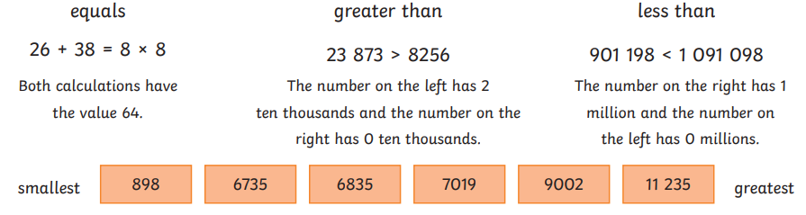
 | Negative numbers
 | Counting in powers of 10
 | 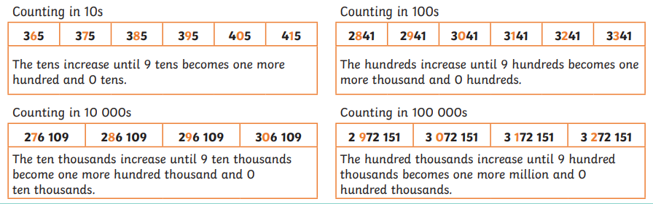
Numbers to one million
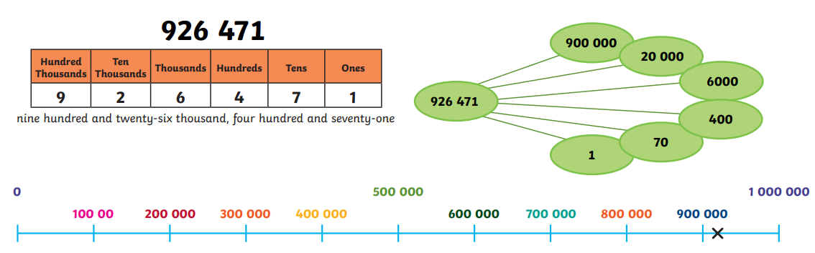
Roman numerals |  |  | Rounding
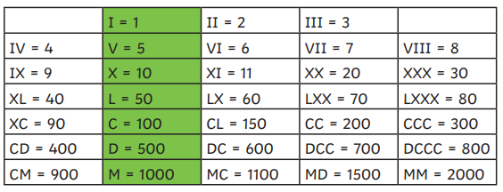 |  |  | 

