Barnham CEVC Primary School Knowledge Organiser
Year 5: Addition and Subtraction |  | Knowledge Organiser
Key Vocabulary | Addition |  |  | Subtraction
add  total  plus  make  sum  more  altogether  difference  subtract  less  minus  take away  change  column addition  column subtraction  estimate  inverse operation  number facts  place value  complex  exchange | 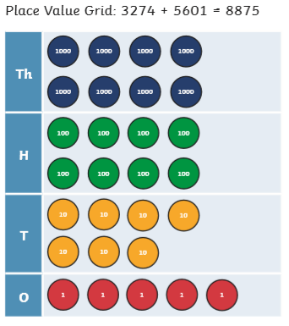  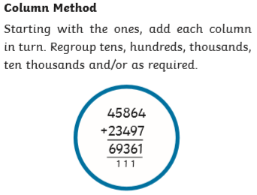 |  |  | 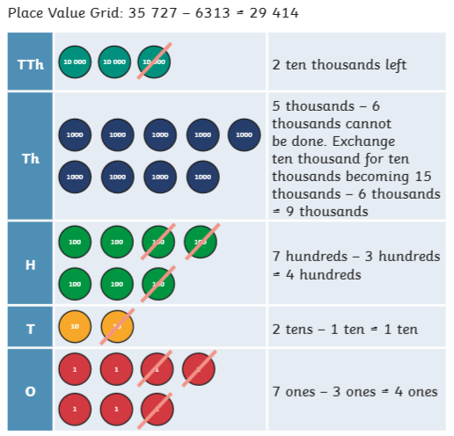  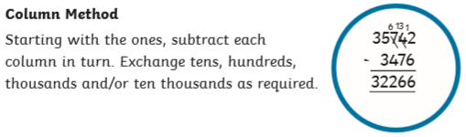
Estimate and Approximate |  |  | Inverse Operations
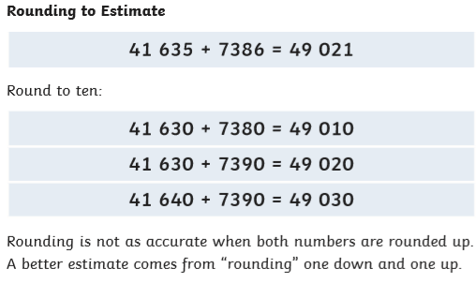  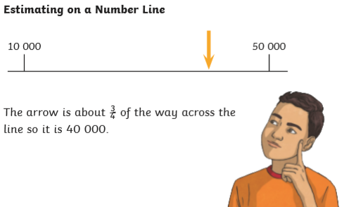 |  |  | 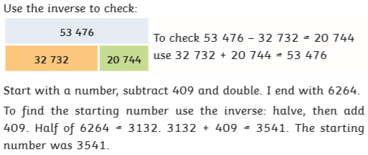
 |  |  | Multi-step problems
 |  |  | 

