Barnham CEVC Primary School Knowledge Organiser
Year 5: Statistics |  | Knowledge Organiser
Key Vocabulary | Reading and understanding tables |  | Completing tables
axis  continuous data  horizontal  data  interpret  label  line graph  maximum value  minimum value  pattern  predict  relationship  represent  scale  survey  table  tally  timetable  vertical  Y axis  X axis | 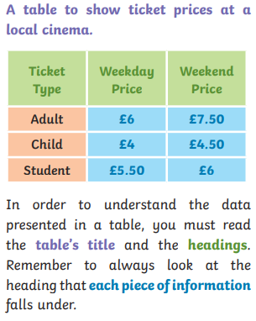 |  | 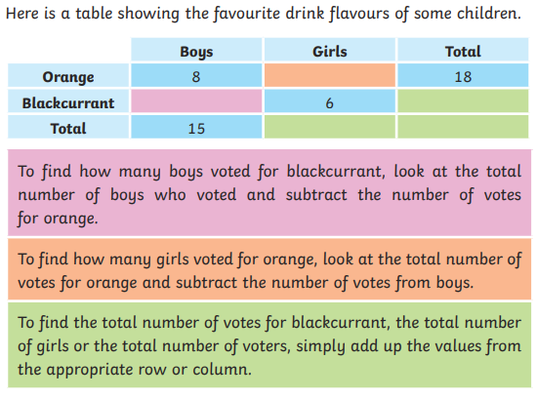
 | Timetables
 | 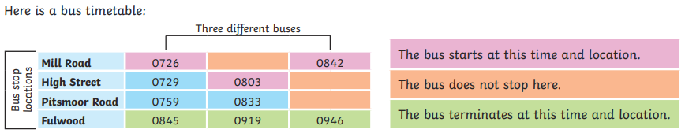
Draw line graphs |  |  |  | Read and interpret line graphs
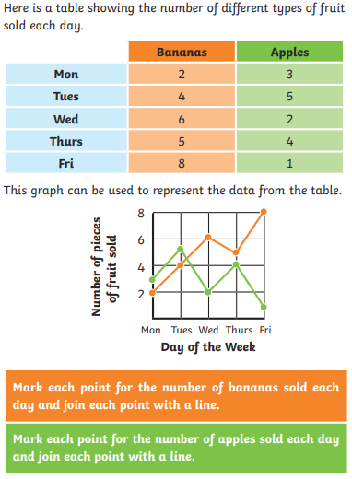 |  |  |  | 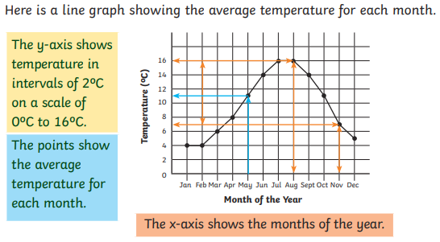
 |  |  |  | Use line graphs to solve problems
 |  |  |  | 

