Barnham CEVC Primary School Knowledge Organiser
Year 5: Multiplication and Division |  | Knowledge Organiser
Key Vocabulary | Factors |  |  |  | Prime Numbers
multiply  groups of  lots of  times  divide  share  group  remainder  factor  multiple  product  prime  cubed  squared  exchange  regroup  place value  place holder | 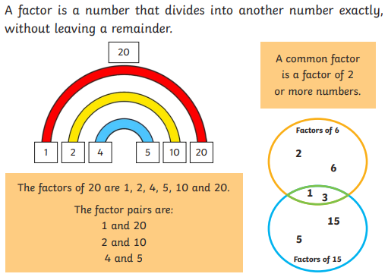 |  |  |  | 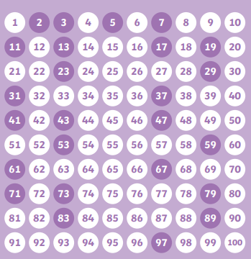
 | Squared or cubed numbers |  |  |  | Related Calculations
 | 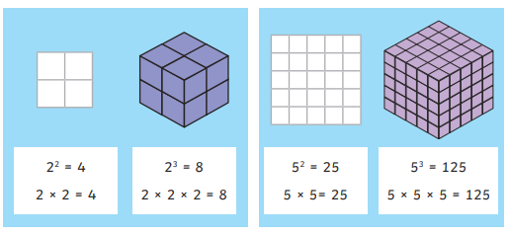 |  |  |  | 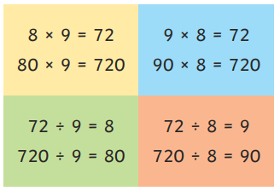
Short Multiplication |  |  |  | Long Multiplication
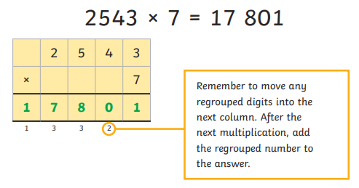 |  |  |  | 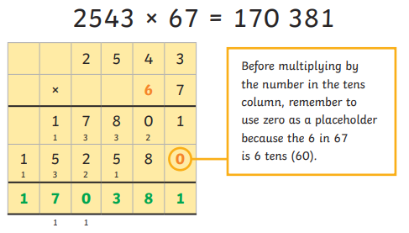
Division |  |  |  | Long Division
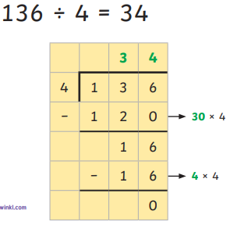 |  |  | 

