Barnham CEVC Primary School Knowledge Organiser
Year 5: Area and Perimeter |  | Knowledge Organiser
Key Vocabulary | Measure Perimeter |  |  | Calculate Perimeter
metre  kilometre  centimetres  millimetres  perimeter  length  width  distance  rectangle  rectilinear  dimensions  area  area covered  squares  squared  rectangles  compound shape  regular  irregular | 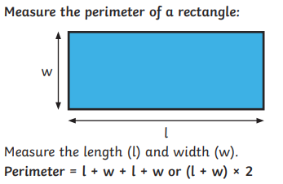 |  |  | 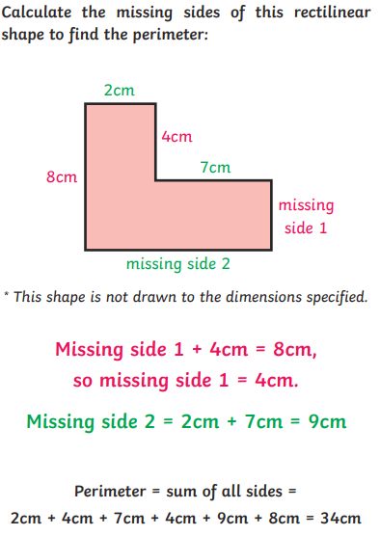
 | 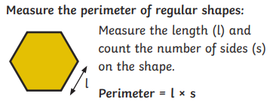
 | 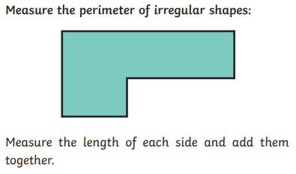
Area of rectangles |  |  | Area of compound shapes |  | Area of irregular shapes
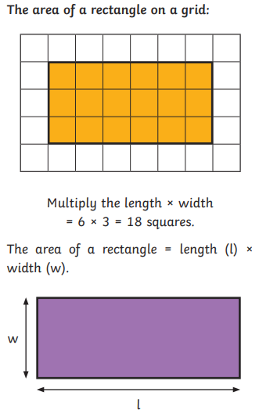 |  |  | 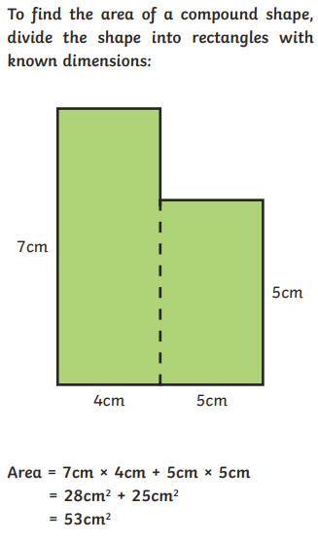 |  | 

