Barnham CEVC Primary School Knowledge Organiser
Year 5: Fractions |  |  | Knowledge Organiser
Key Vocabulary | Equivalent Fractions |  |  | Compare and order fractions
Numerator  Denominator  Unit fraction  Non-unit fraction  Whole  Equivalent  Mixed number  Improper fraction  Simplest form  Multiple  Common denominator  Common numerator  Top heavy  Parts  Bar model | 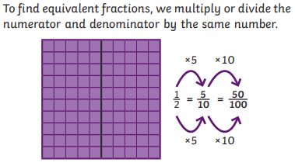 |  |  | 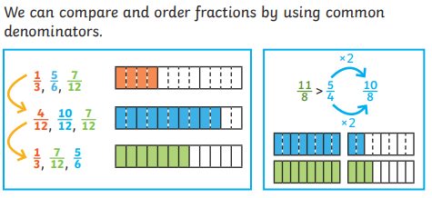
 | Mixed numbers |  |  | Improper fractions
 | 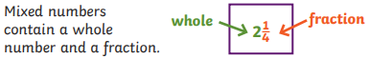 |  |  | 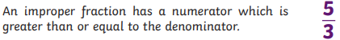
 | Convert improper to mixed number |  |  | Convert a mixed number to improper
 | 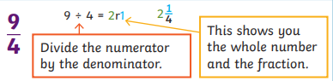 |  |  | 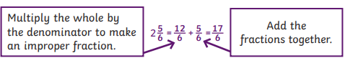
 | Adding and subtracting fractions
 | 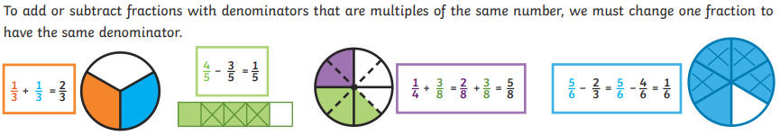
Add fractions where the total is greater than 1 |  |  |  | Subtract from a mixed number
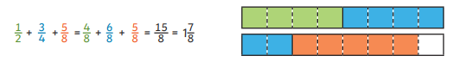 |  |  |  | 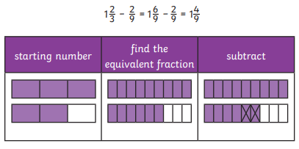
Add mixed numbers
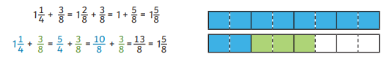
Multiply fractions by integers |  |  |  | Subtract two mixed numbers
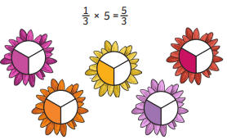 |  | 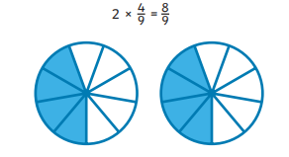 |  | 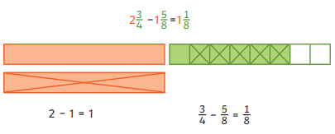
Multiply mixed numbers by integers |  |  |  | Subtract from a mixed number
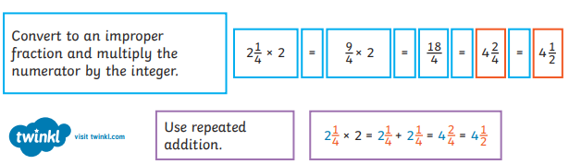 |  |  |  | 

