Barnham CEVC Primary School Knowledge Organiser
Year 5: Decimals |  | Knowledge Organiser
Key Vocabulary | Tenths, hundredths and thousandths |  |  | Order and compare numbers with 3dp.
tenths  hundredths  thousandths  part/whole  equivalents  decimal  1dp.  2dp.  3dp.  rounding  decimal point  place value  percentage  out of 100 | 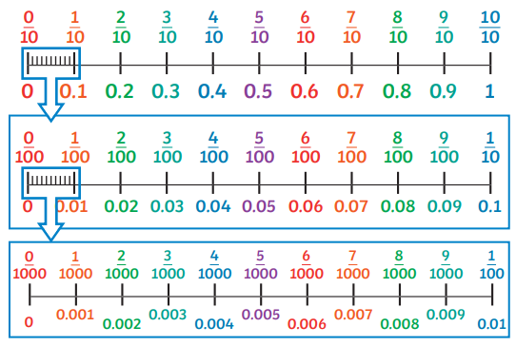  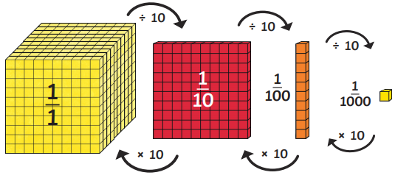 |  |  | 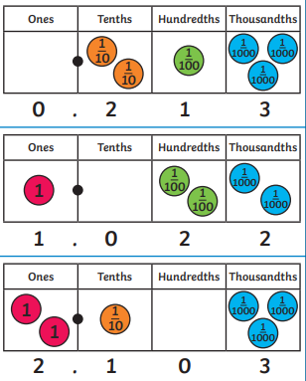
 |  |  |  | Decimal numbers as fractions
 |  |  |  | 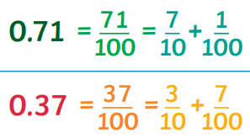
Multiplying and dividing by 10, 100 and 1000 |  |  | Rounding decimals
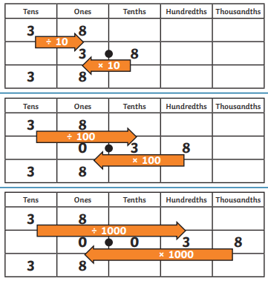 |  |  | 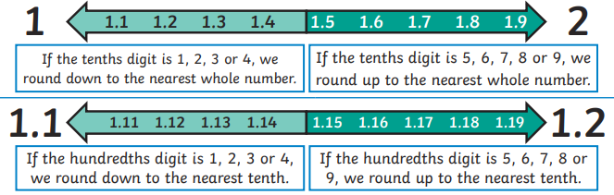
Percentages and decimal equivalents

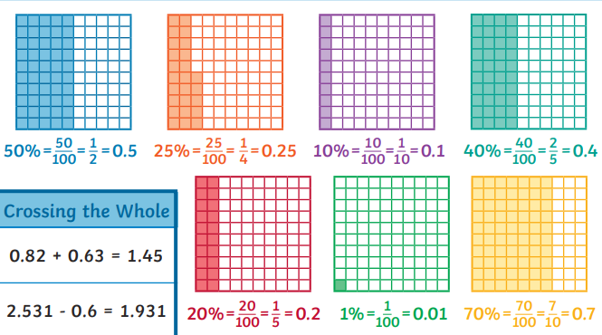
Adding and subtracting decimals


