Barnham CEVC Primary School Knowledge Organiser
Year 5: Properties of Shape |  | Knowledge Organiser
Key Vocabulary | Properties of 3D Shape |  | Regular and irregular polygons
angle  right angle  acute  obtuse  reflex  protractor  horizontal  vertical  diagonal  parallel  perpendicular  regular  irregular  2D/3D  polygon  flat face  curved face  edge  curved edge  vertex  apex | 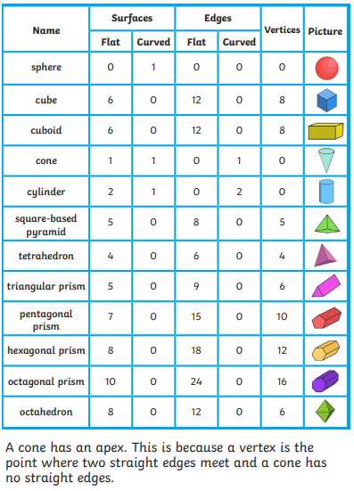 |  | 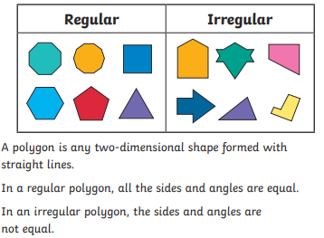
 |  |  | Representations
 |  |  | 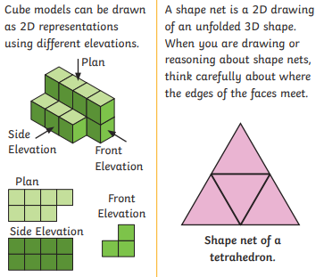
Identify angles
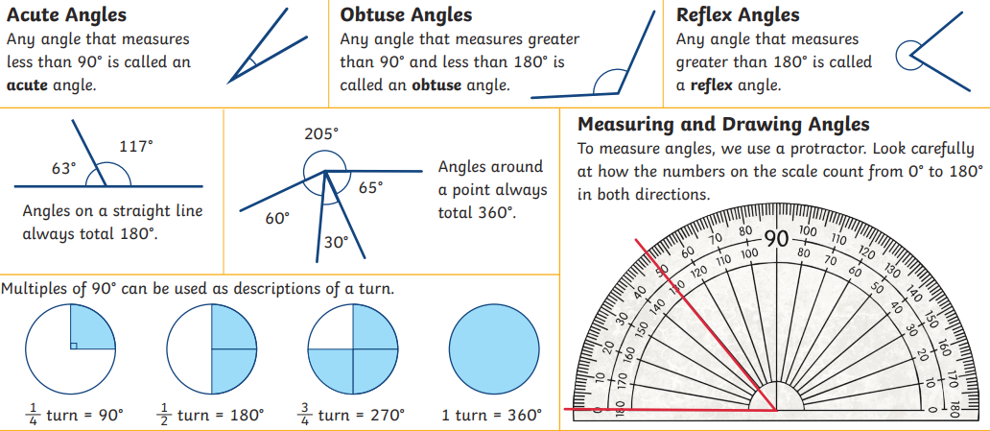
Using properties of rectangles


