Barnham CEVC Primary School Knowledge Organiser
Year 5: Position and Direction |  | Knowledge Organiser
Key Vocabulary | Position in the first quadrant
coordinate  quadrant  X axis  Y axis  translation  reflection  mirror line  horizontal  vertical  vertex  vertices  plotting  2D  along the corridor  up the stairs  position | 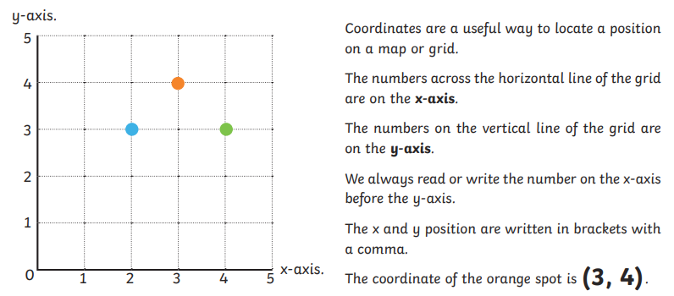
 | 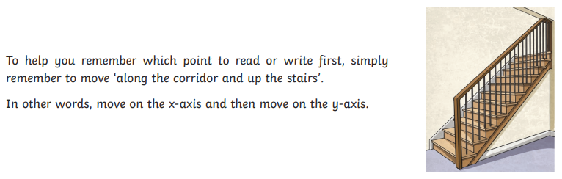
Translation |  |  | Reflection
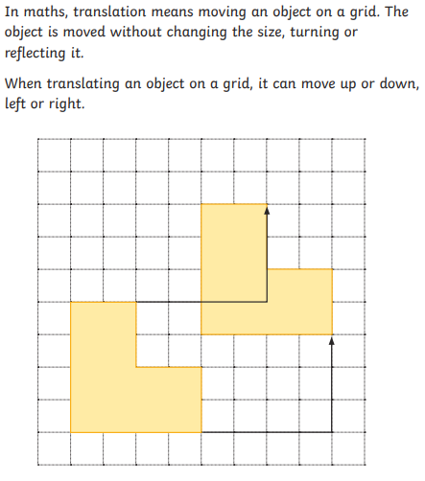 |  |  | 

