Barnham CEVC Primary School Knowledge Organiser
Year 5: Converting Units |  | Knowledge Organiser
Key Vocabulary | Converting Mass |  | Converting Capacity
mass  gram  kilogram  capacity  volume  millilitres  litres  centilitre  length  millimetre  centimetres  metres  kilometres  minute  hour  day  weeks  fortnight  months  years | 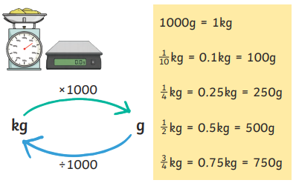 |  | 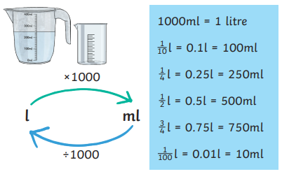
 | Converting Length
 | 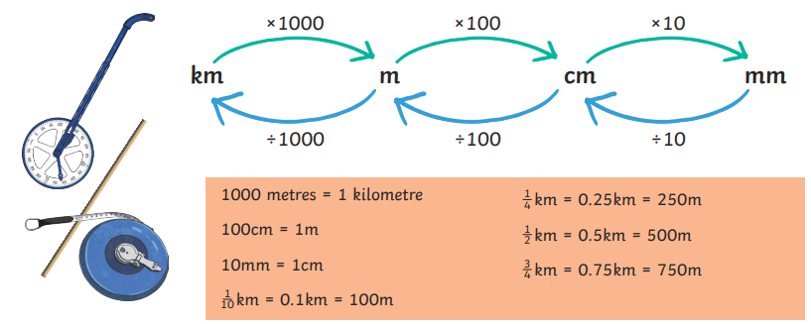
Units of Time


