Barnham CEVC Primary School Knowledge Organiser
Year 6: Four Operations |  | Knowledge Organiser
Key Vocabulary | Add and subtract whole numbers
add  total  make  plus  sum  more  altogether  difference  leave  subtract  difference between  less  minus  column addition  column subtraction  take away  estimate  inverse  complex  multistep  place value | 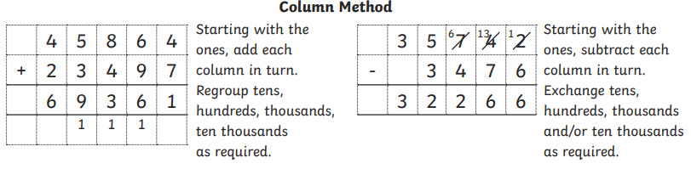
 | Multiply up to 4 digits by 2 digits |  | Order of operations
 | 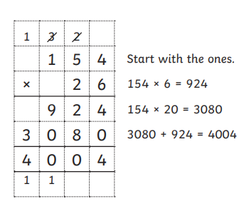 |  | 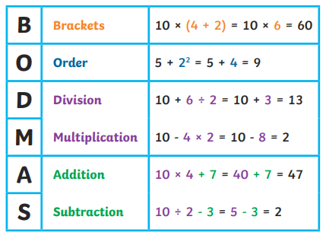
multiply  product  groups of  lots of  division  divide  share  group  exchange  regroup  long multiplication  short multiplication  short division  long division  number facts  solve problems  word problems  repeated addition  prime numbers  multiples  factors  BODMAS | Four operations
 | 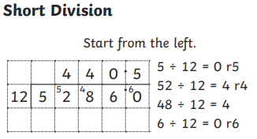 |  | 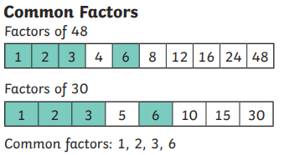
 | 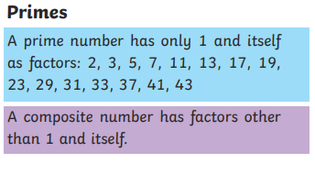 |  | 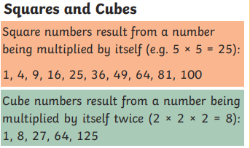
 | 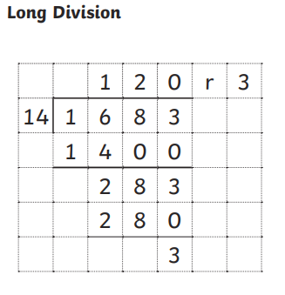 |  | 

