Barnham CEVC Primary School Knowledge Organiser
Year 6: Fractions |  | Knowledge Organiser
Key Vocabulary | Simplify Fractions |  | Compare and Order Fractions
numerator  denominator  improper fraction  proper fraction  factor  highest common multiple  lowest common multiple  equivalents  common denominator  simplify  decimal equivalent  simplest form  mixed number  whole number  same  parts  equivalent | 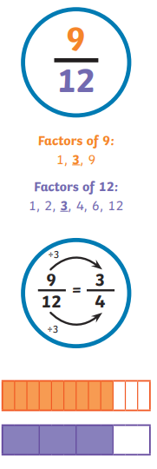 |  | 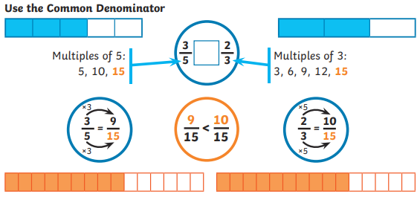  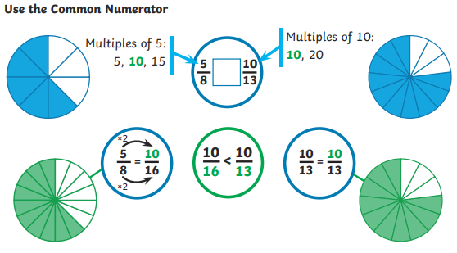
Adding and subtracting improper fractions |  |  |  | Adding and subtracting mixed numbers
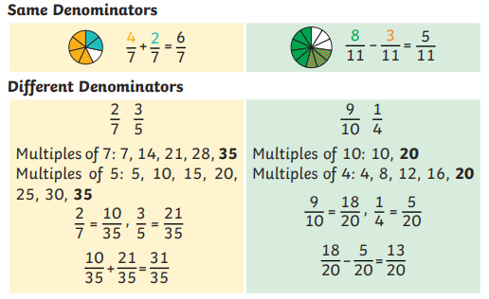 |  |  |  | 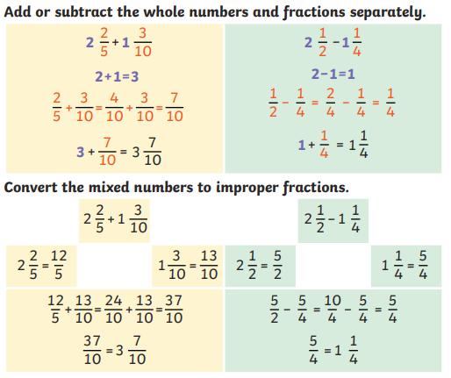
Multiplying proper fractions |  |  |  | Dividing fractions by whole numbers
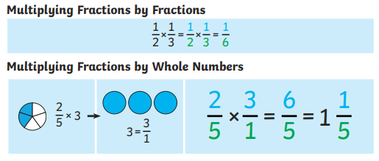 |  |  |  | 

